***Practical 2: To implement Various Hadoop HDFS Commands***

**Steps involved how to implement Various Hadoop HDFS Commands below in the following order-**

1. **hadoop version** is used to check version of Hadoop system.

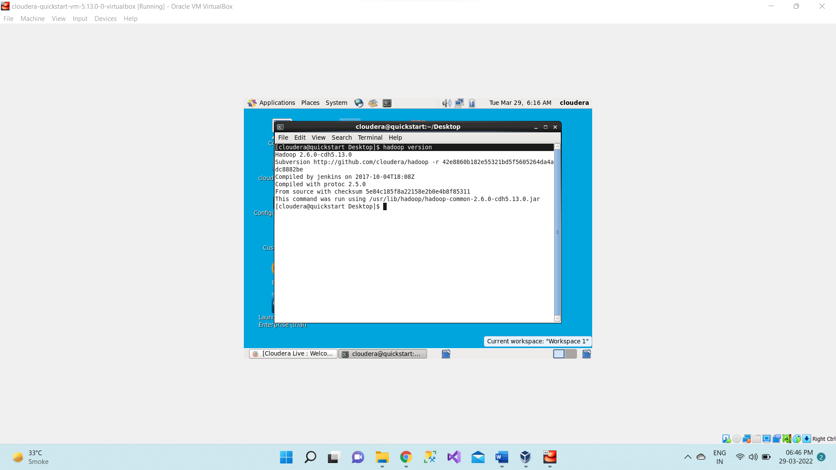

1. **hdfs dfs -ls /** lists all the files and folders present in HDFS location. It lists the contents of the directory specified by path, names, permissions, owner, size and modification date for each entry. hdfs dfs is the command specific to HDFS.

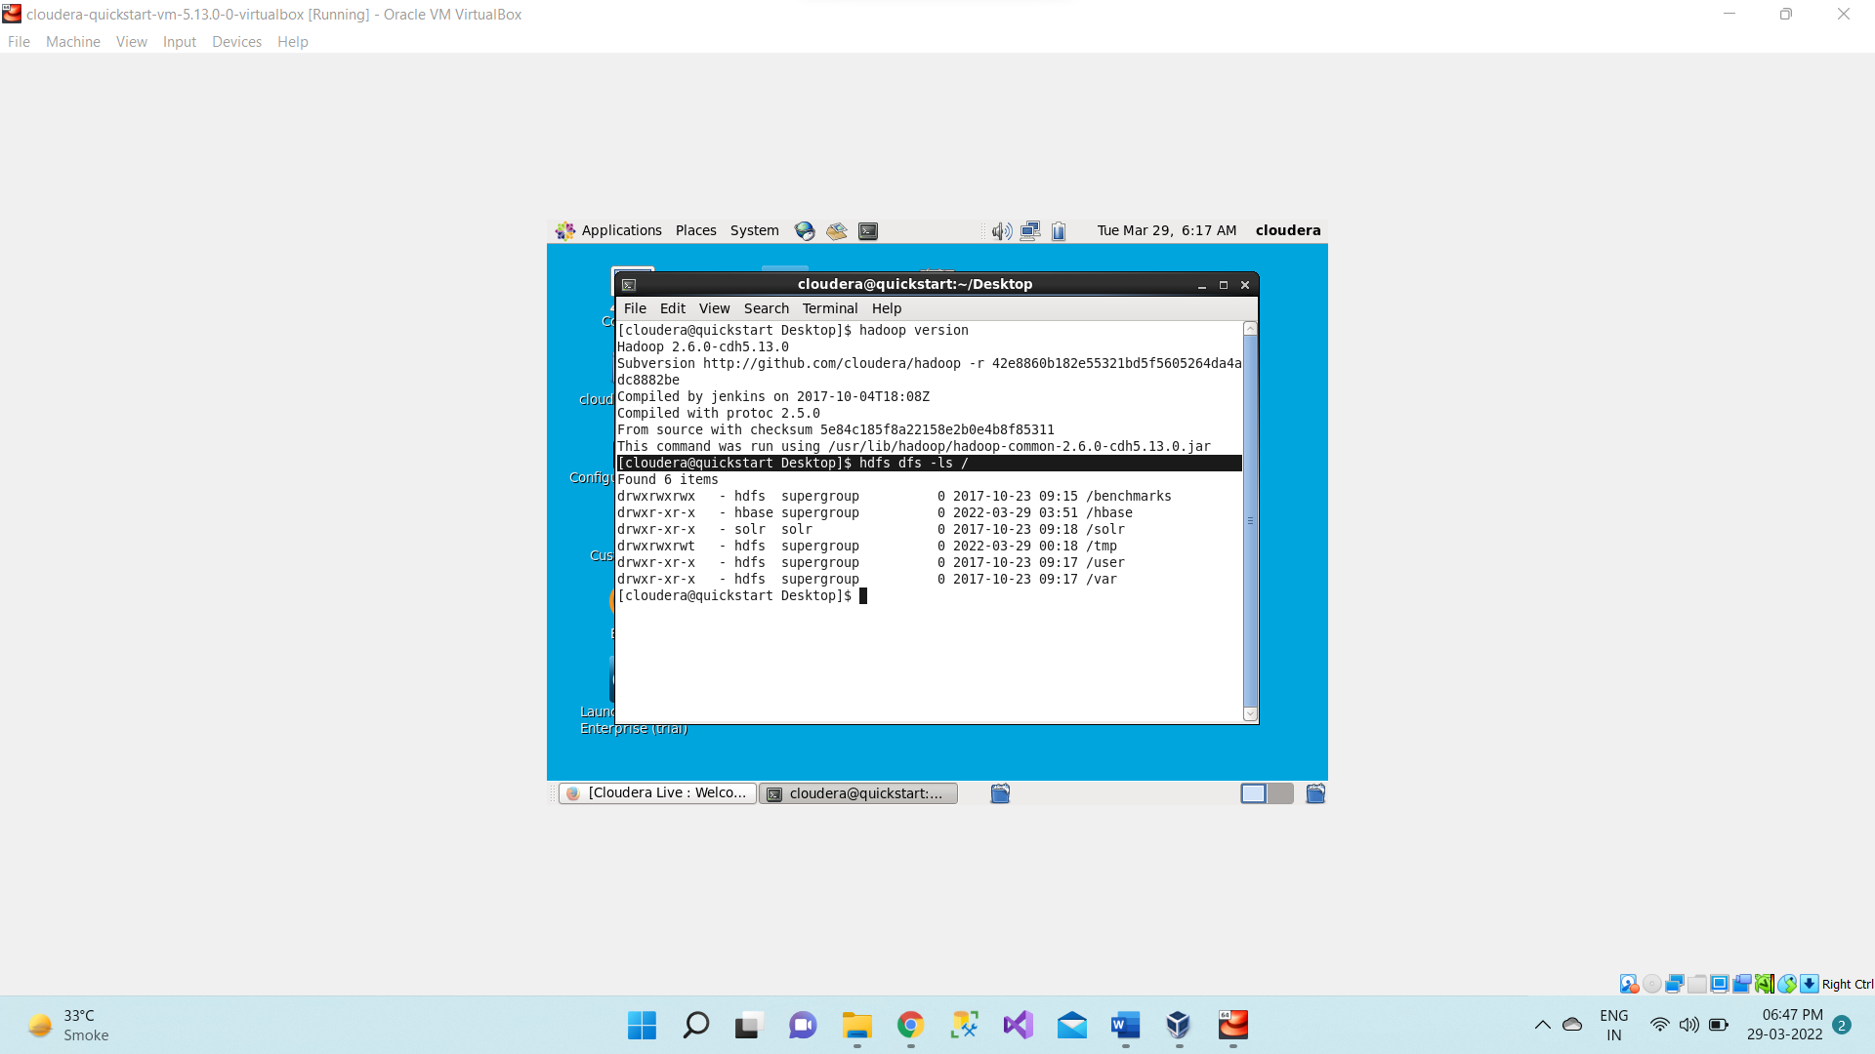

1. **hdfs dfs -mkdir /rjclocal**

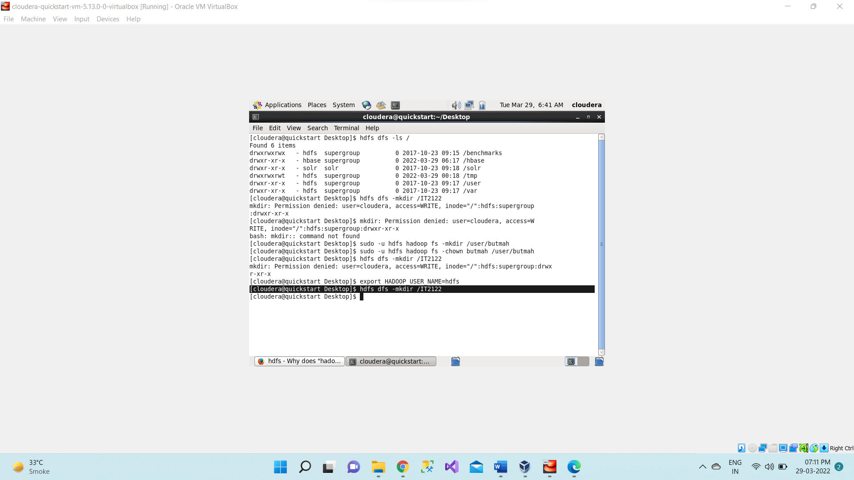

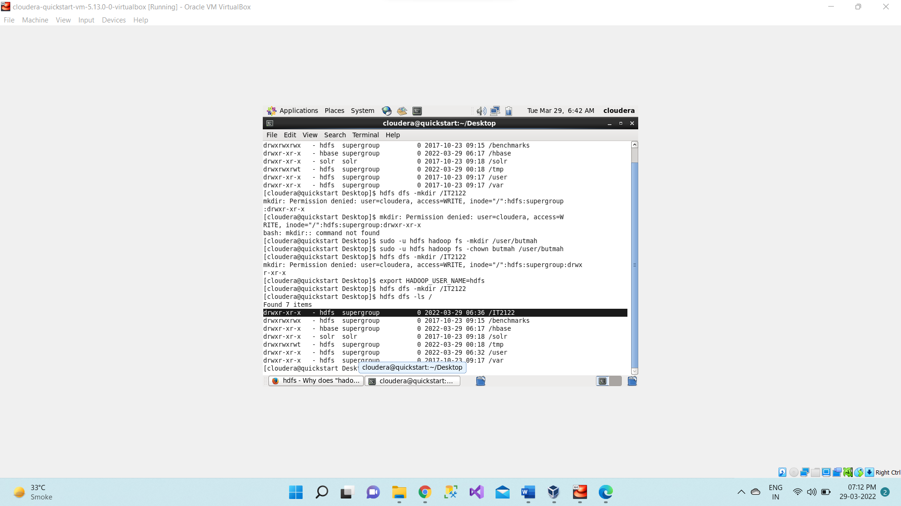

1. **Create a new file on desktop**

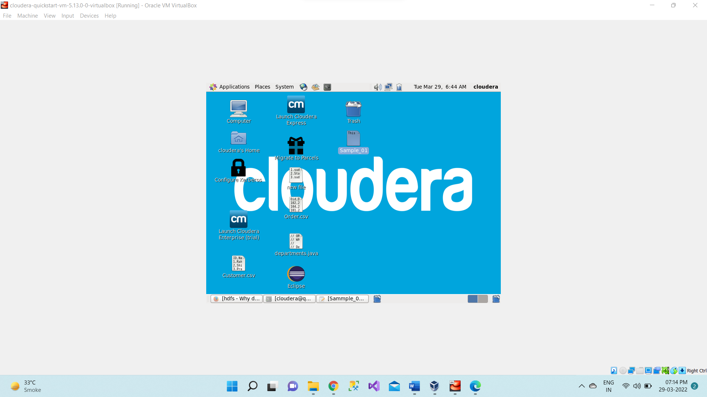

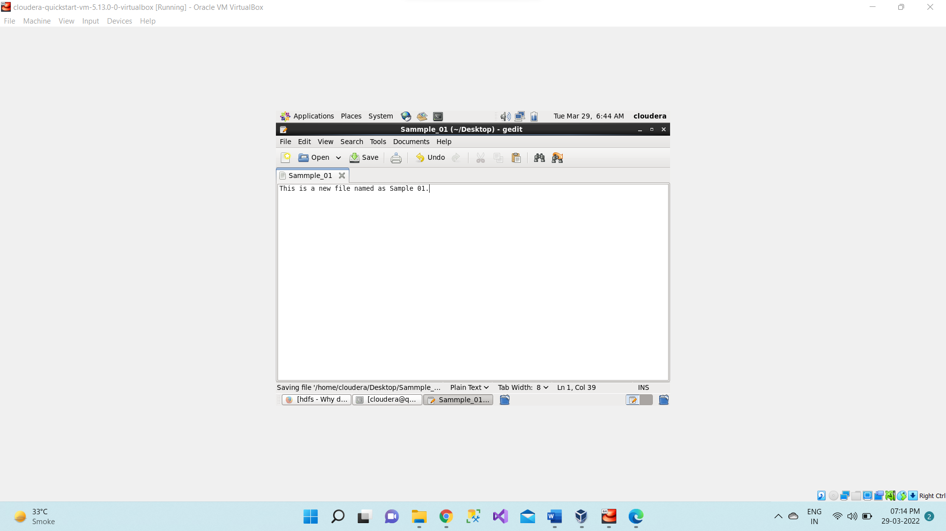

1. Use **hdfs dfs -copyFromLocal /home/cloudera/Desktop/<file_name> /<directory_name>**- this command copies **<file_name>** file to HDFS **<directory_name>** directory.

use **hdfs dfs -ls /rjclocal** to check is file is successfully copied

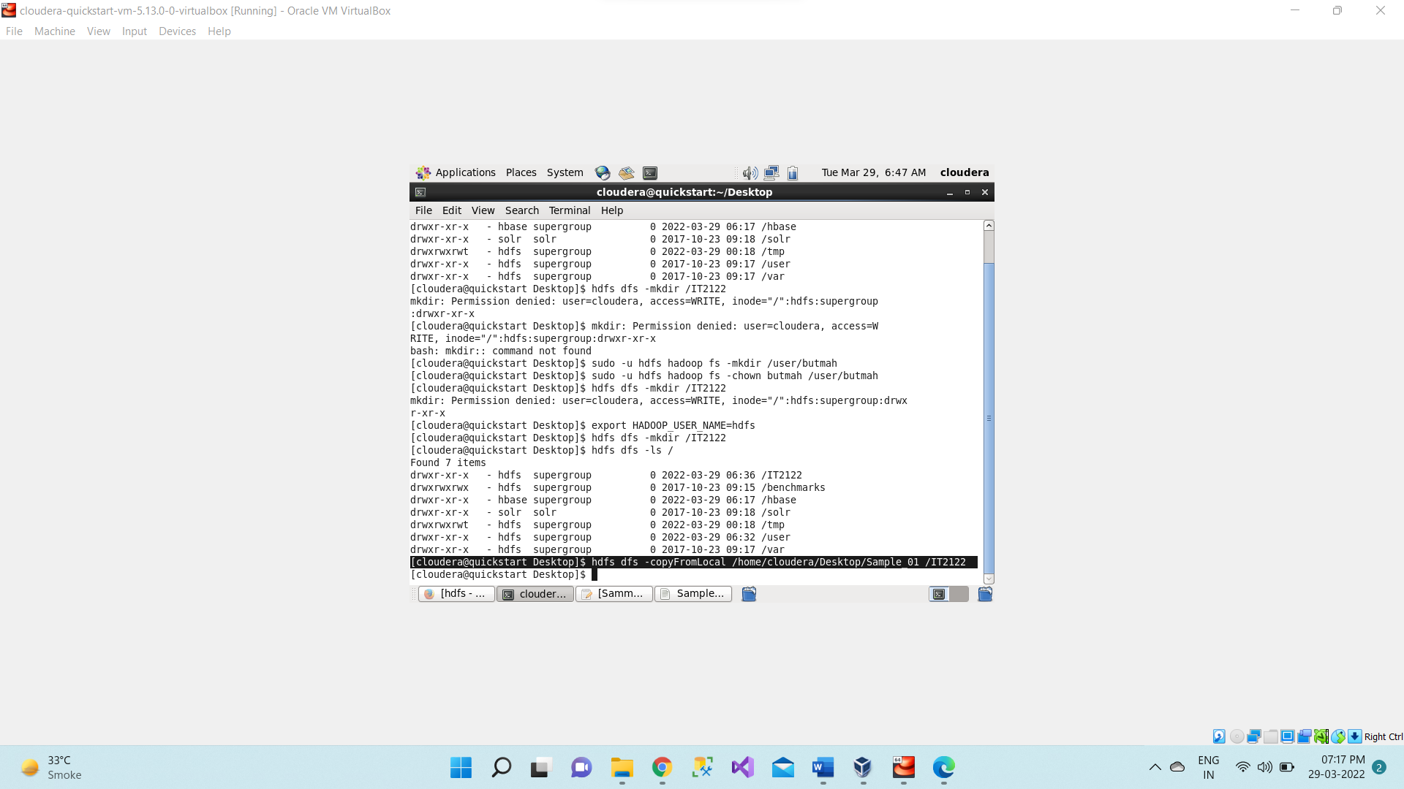

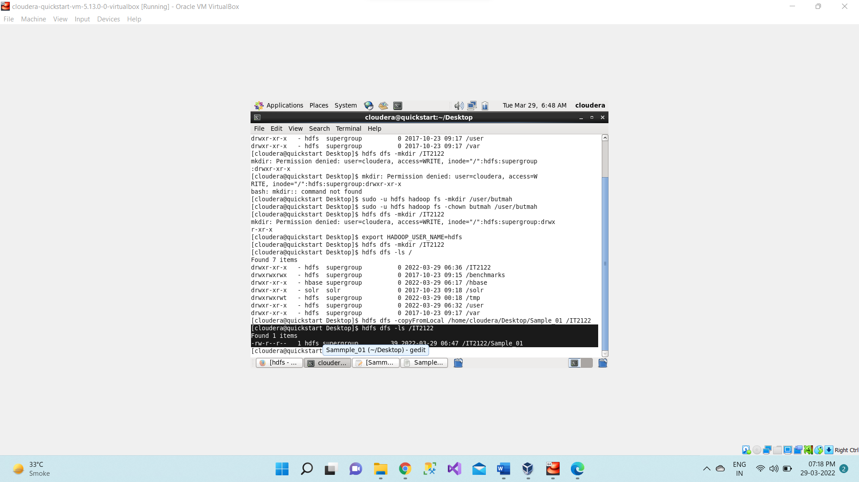

1. **hdfs dfs -cat /<directory_name>/<file_name>** reads content of file.

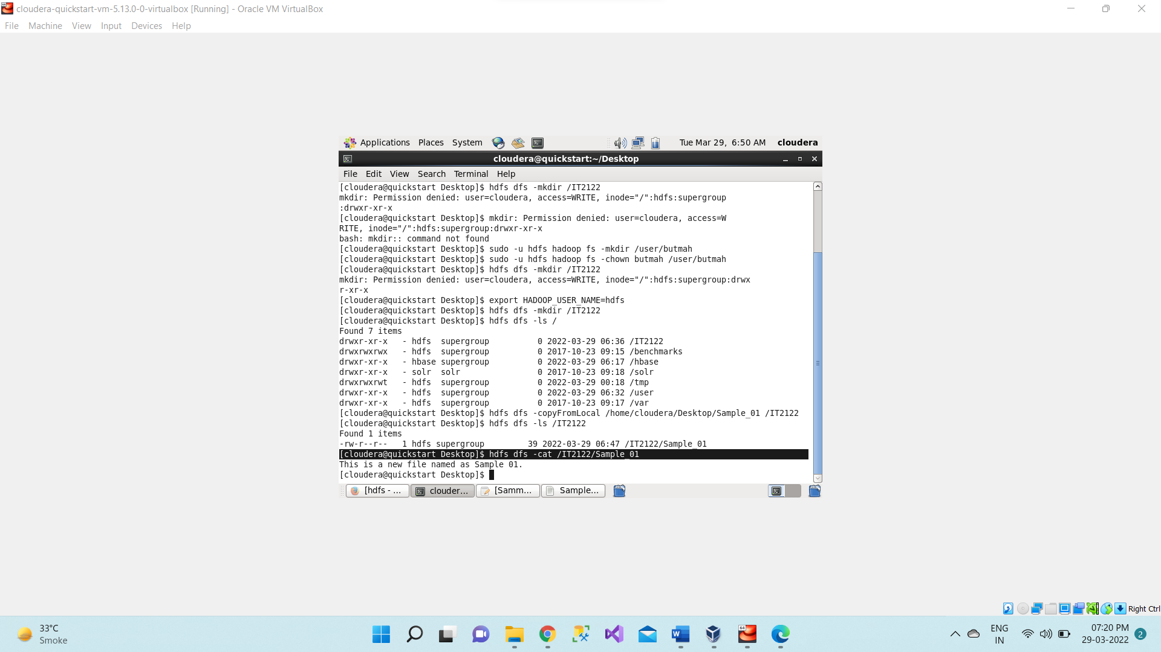

1. First we create a new directory in HDFS “**newdir**” **hdfs dfs -mkdir /<dir_name>** and then use

**hdfs dfs -cp /<dir1_name>/<dir_file_name> /<dir2_name>** then check if file is copied successfully by using

**hdfs dfs -ls /<dir2_name>** **cp** command is used to copy file from one directory to another within HDFS

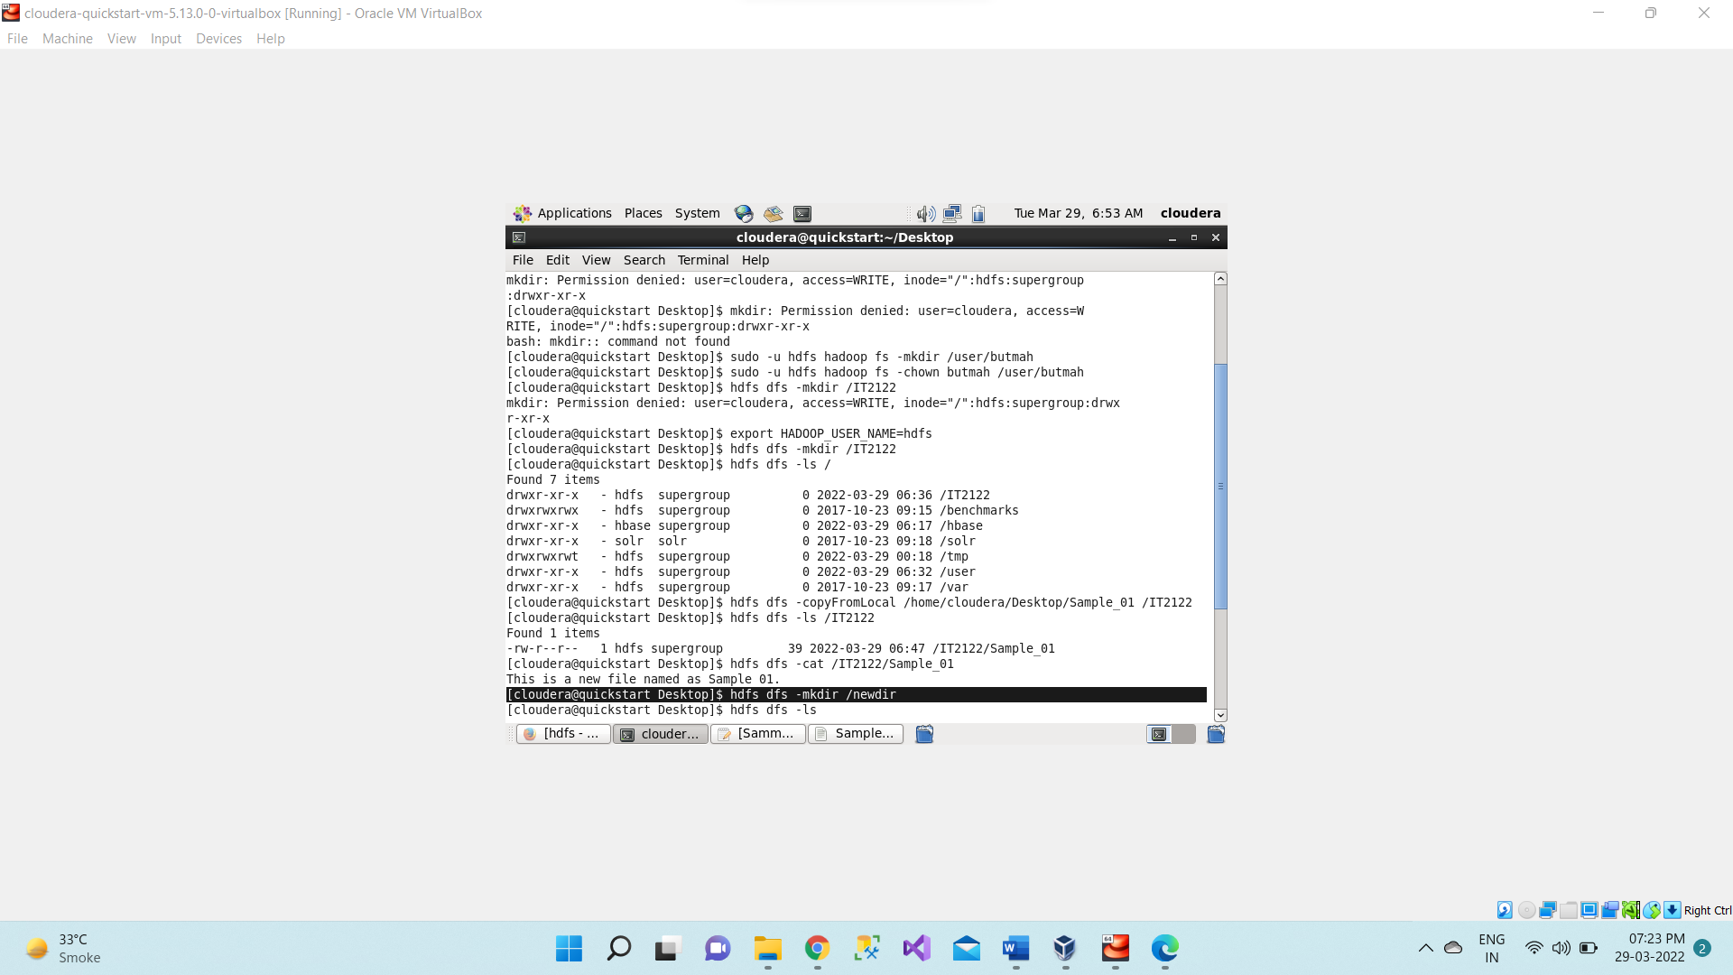

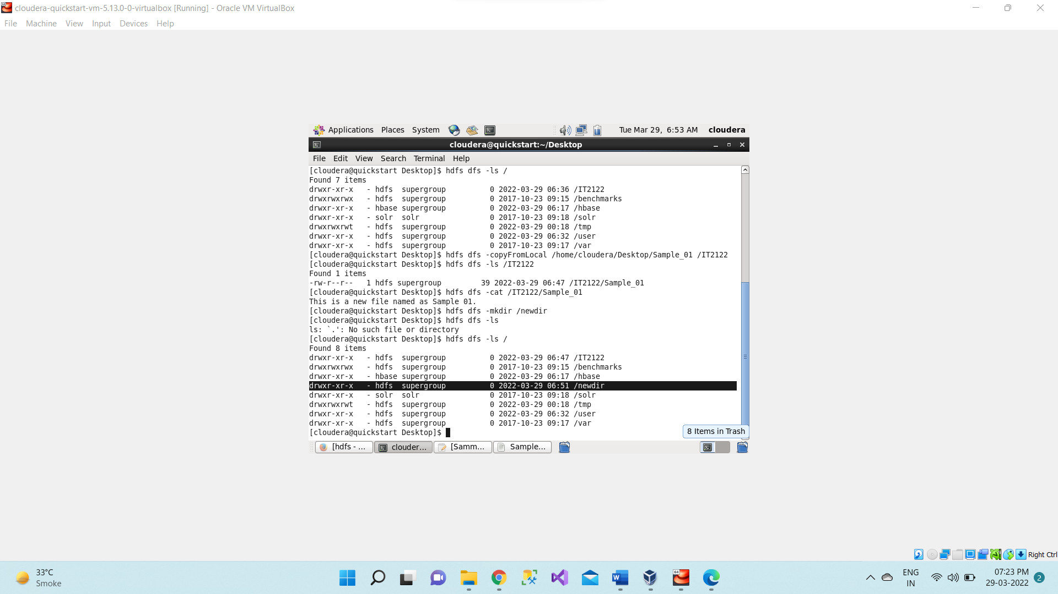

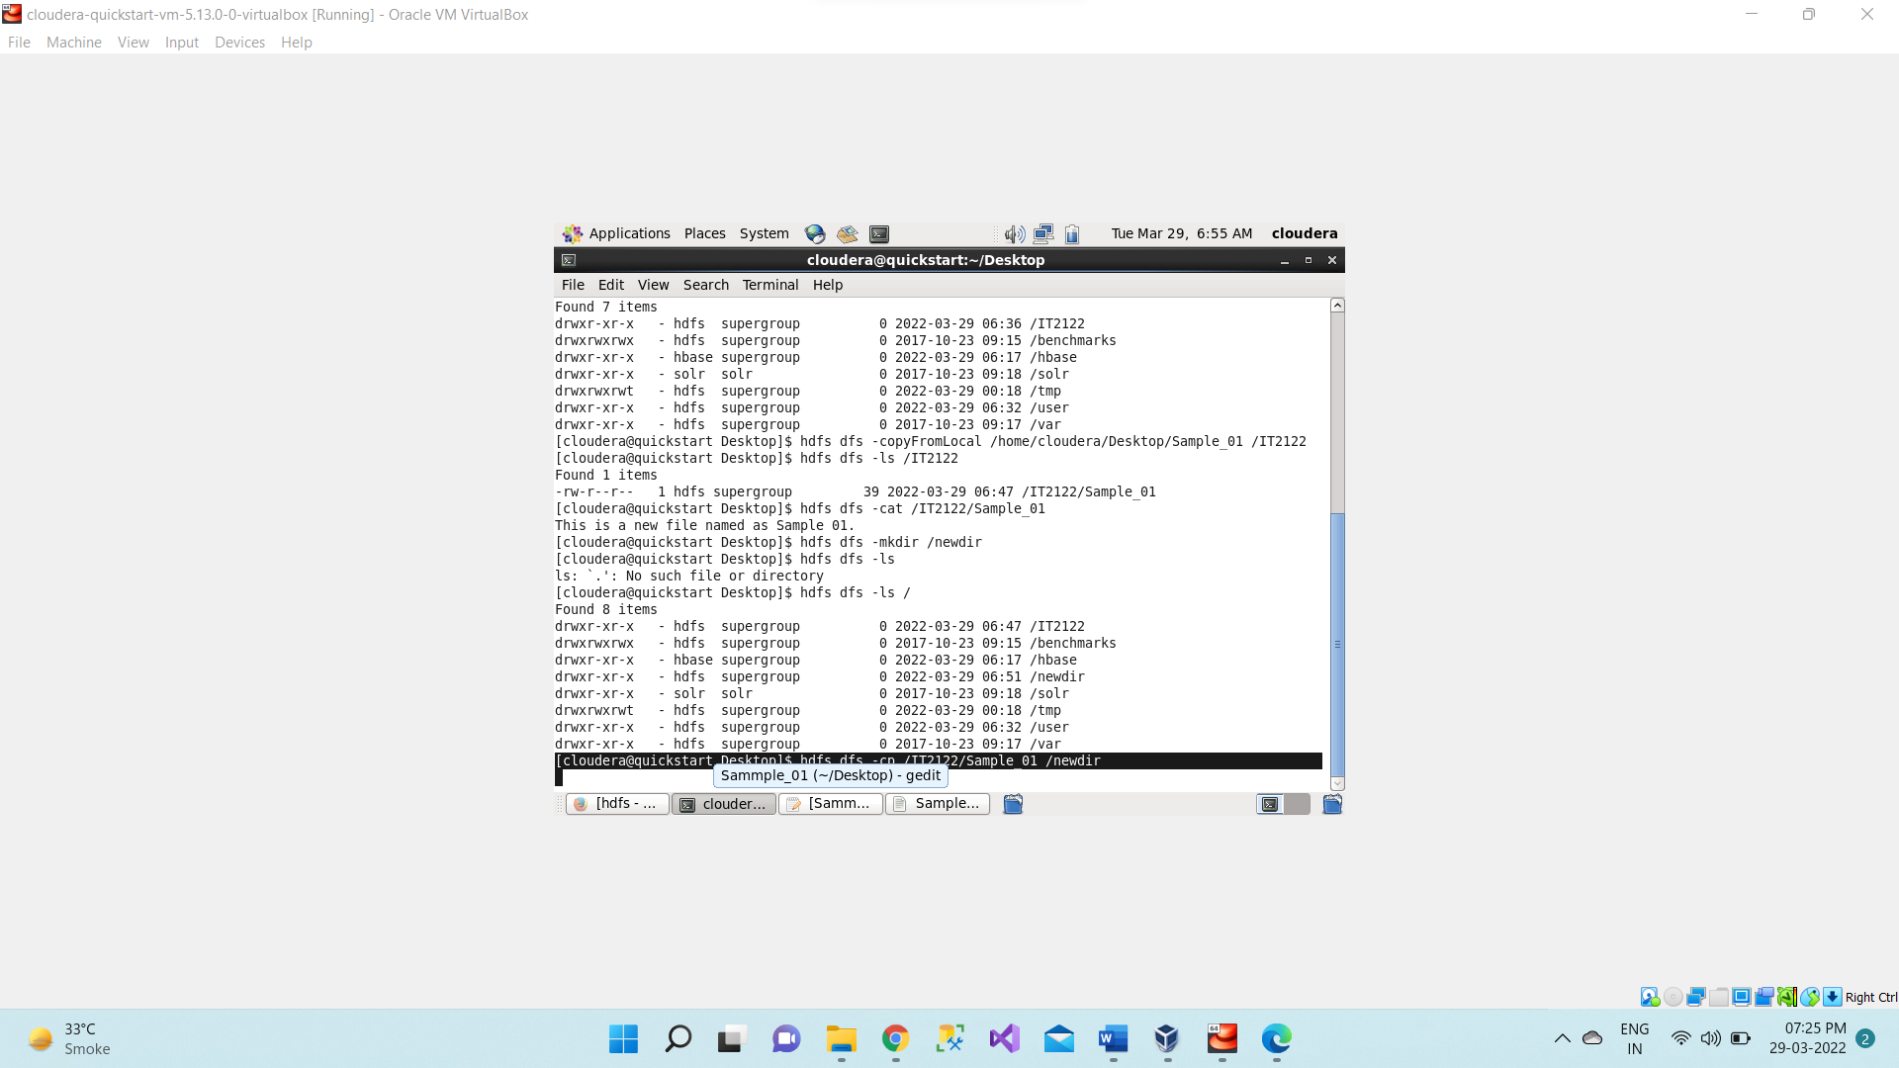

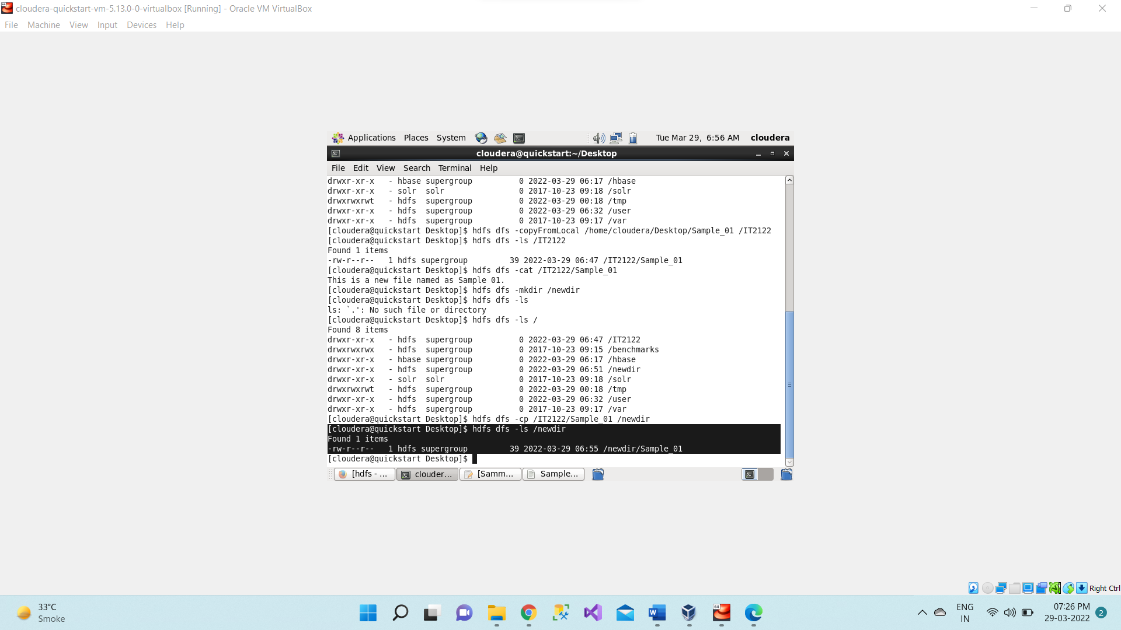

1. **hdfs dfs -mv /<dir1_name>/<file1_name> /output_abc** moves file <file1_name> from source to destination within HDFS

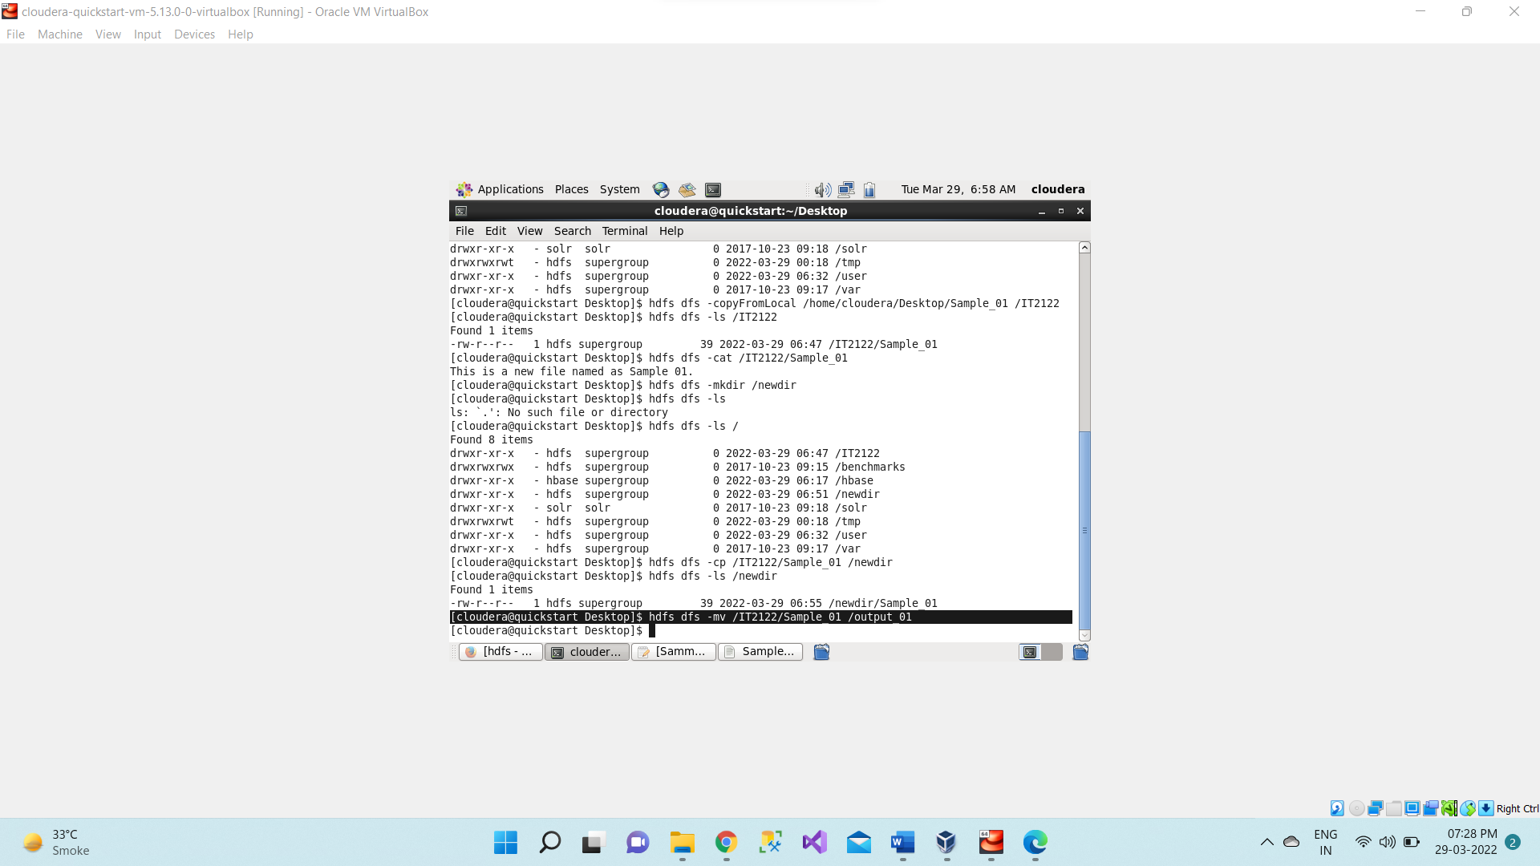

**After moving file source folder to destination folder**

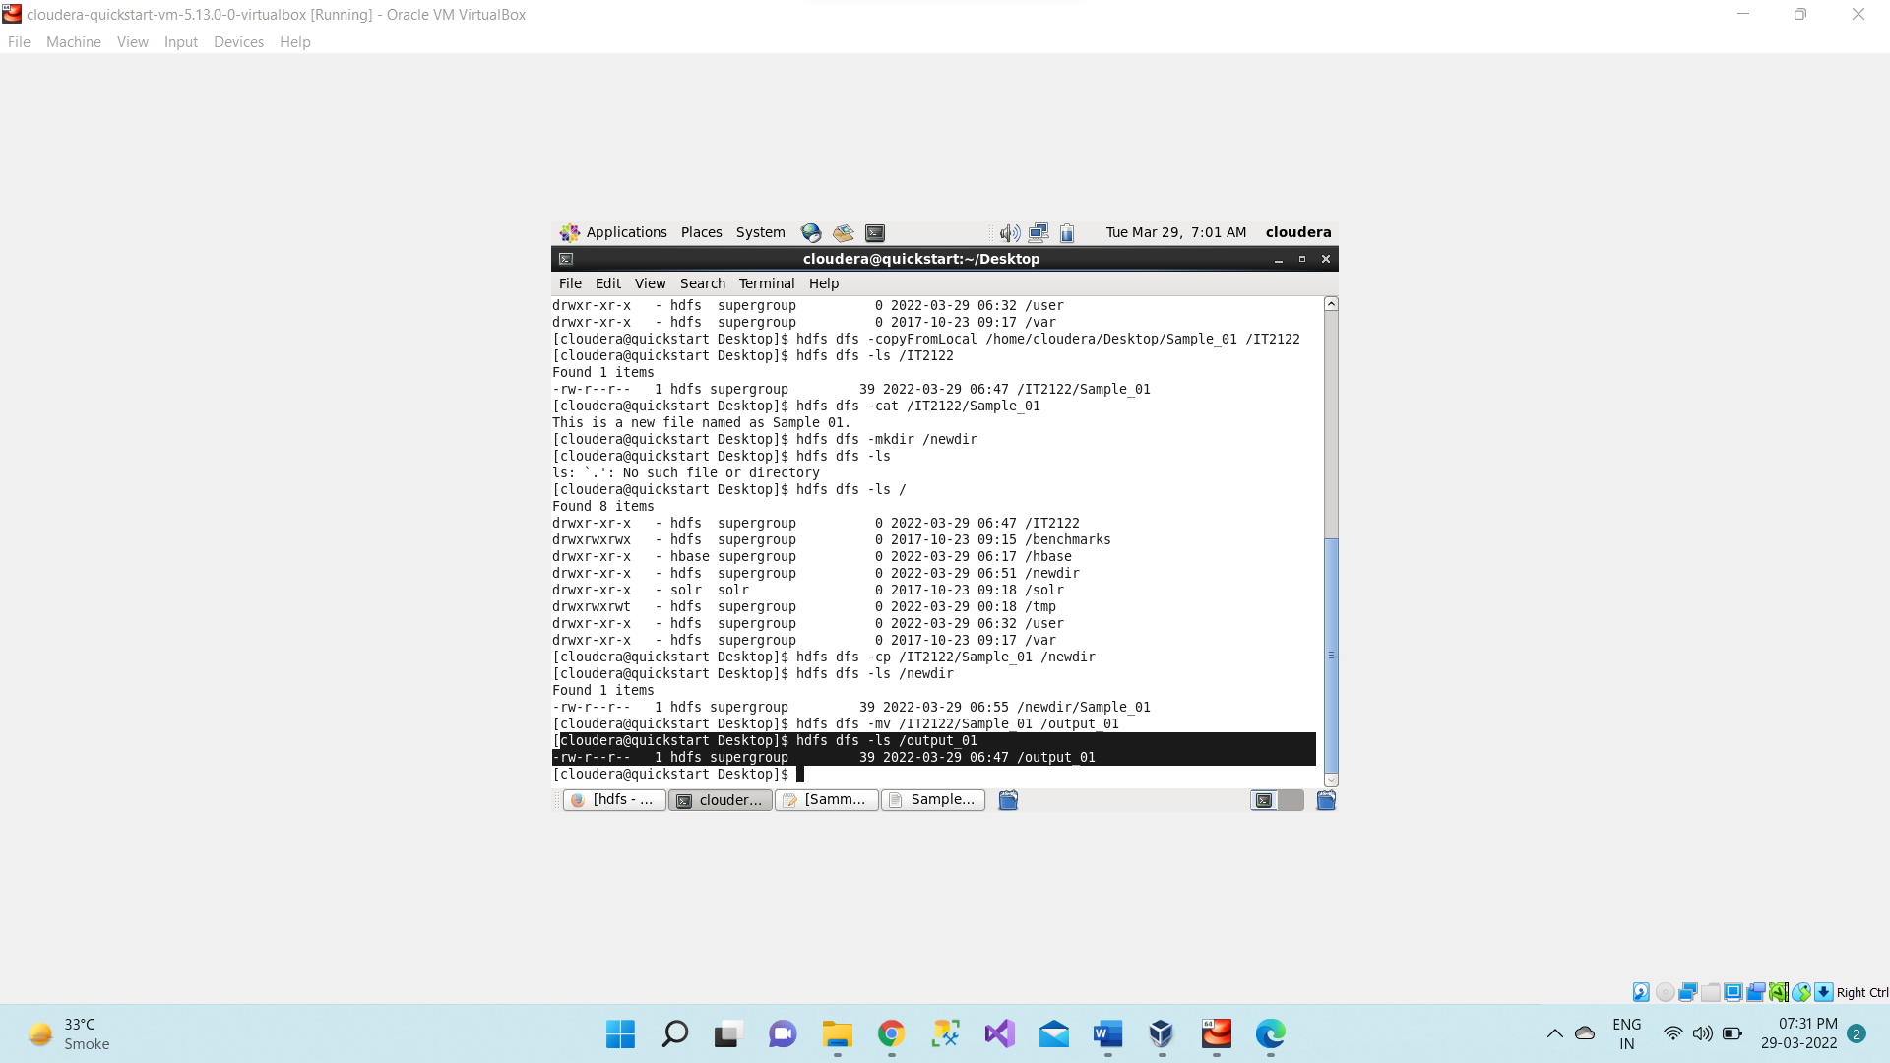

Use **hdfs dfs -cat /<file1_name>** command to read moves file.

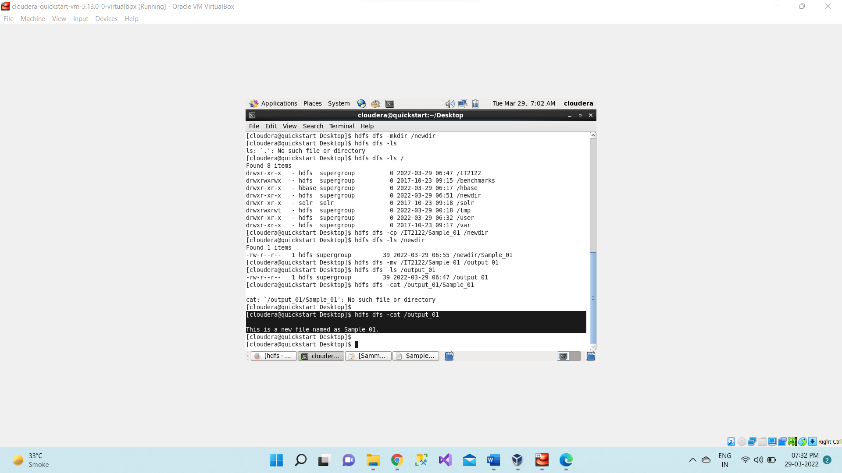

1. **hdfs dfs -rm /<dir_name>/<file_name>** deletes objects and directories full of objects.

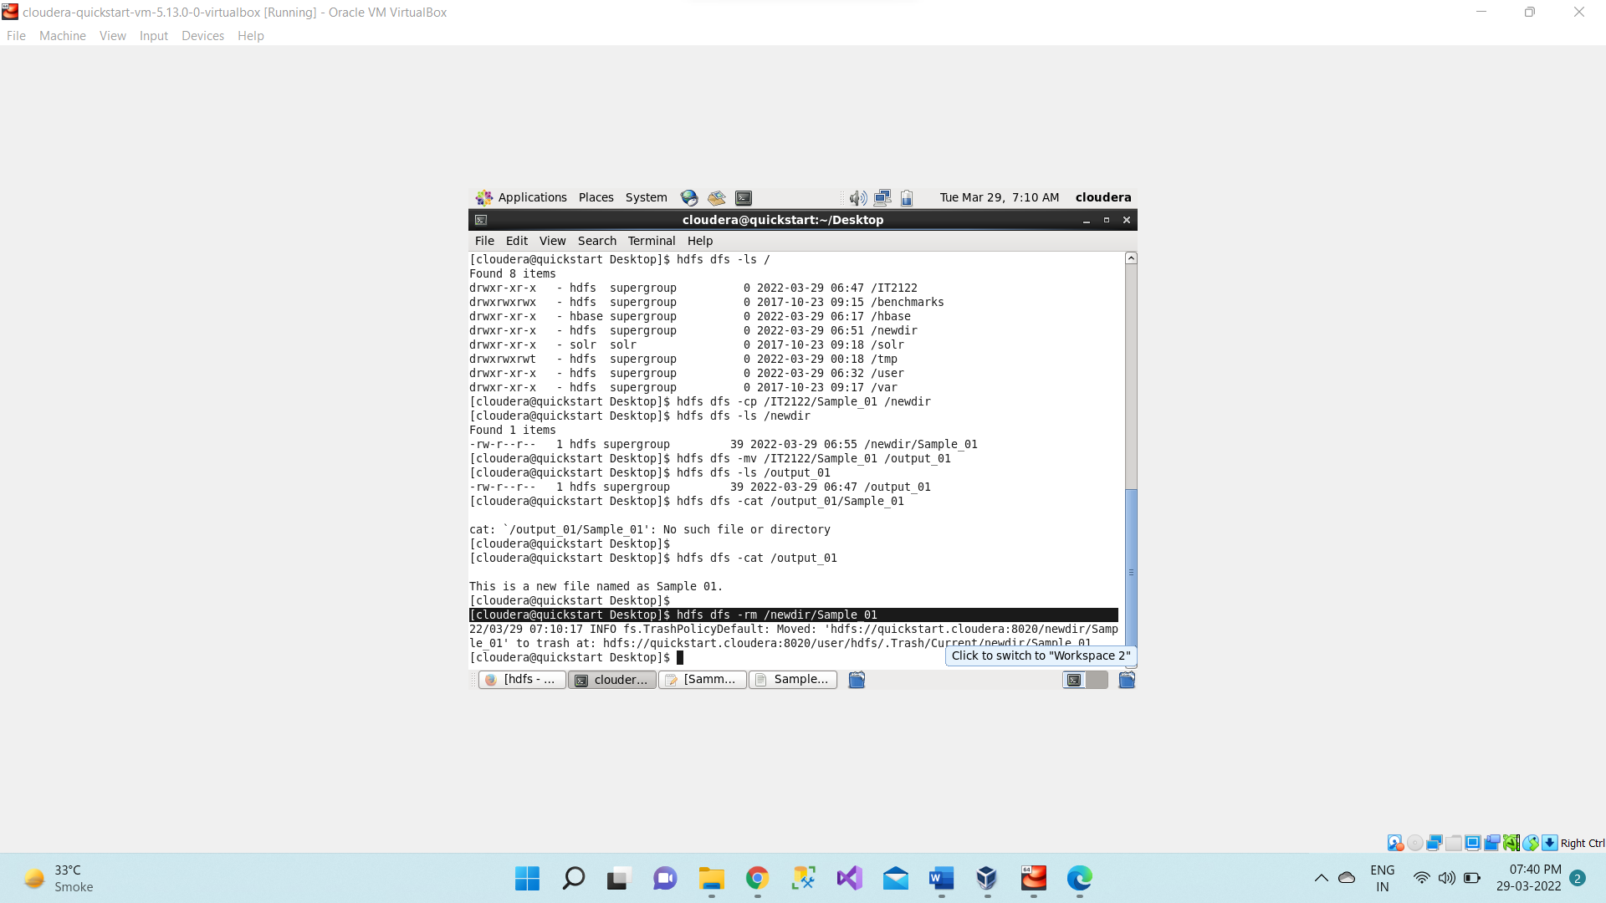

1. **hdfs dfs -rm -r /output_abc** removes directory with objects

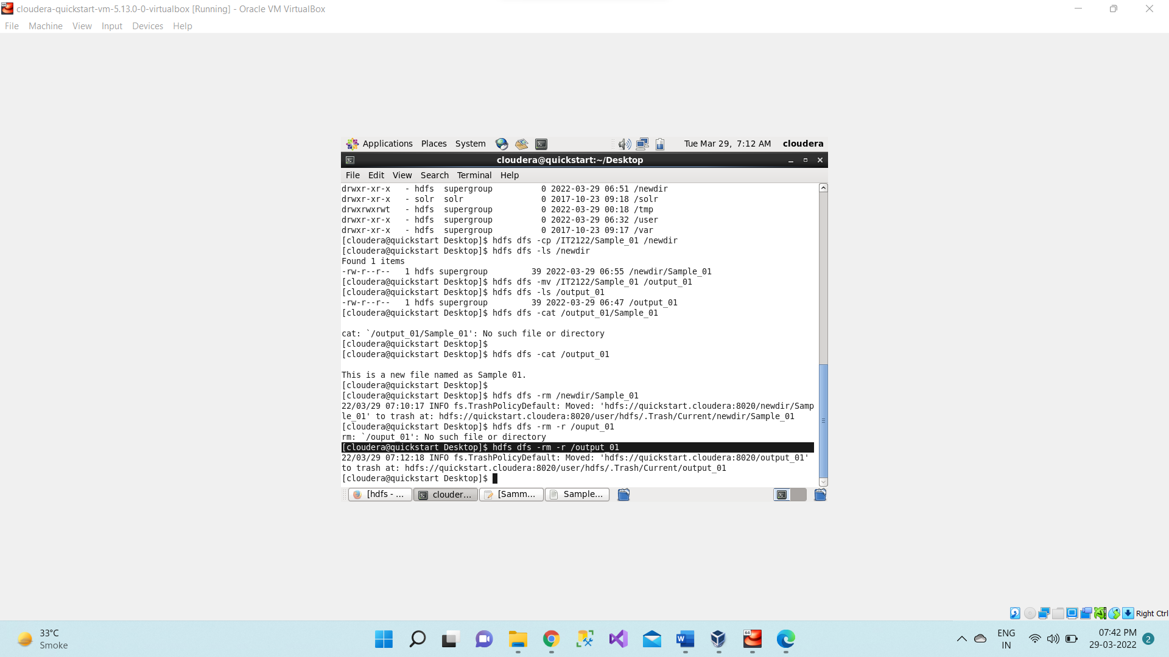

1. **hdfs dfs -moveFromLocal /home/cloudera/Desktop/<file_name> /<dir_name**> moves files from local file system to HDFS

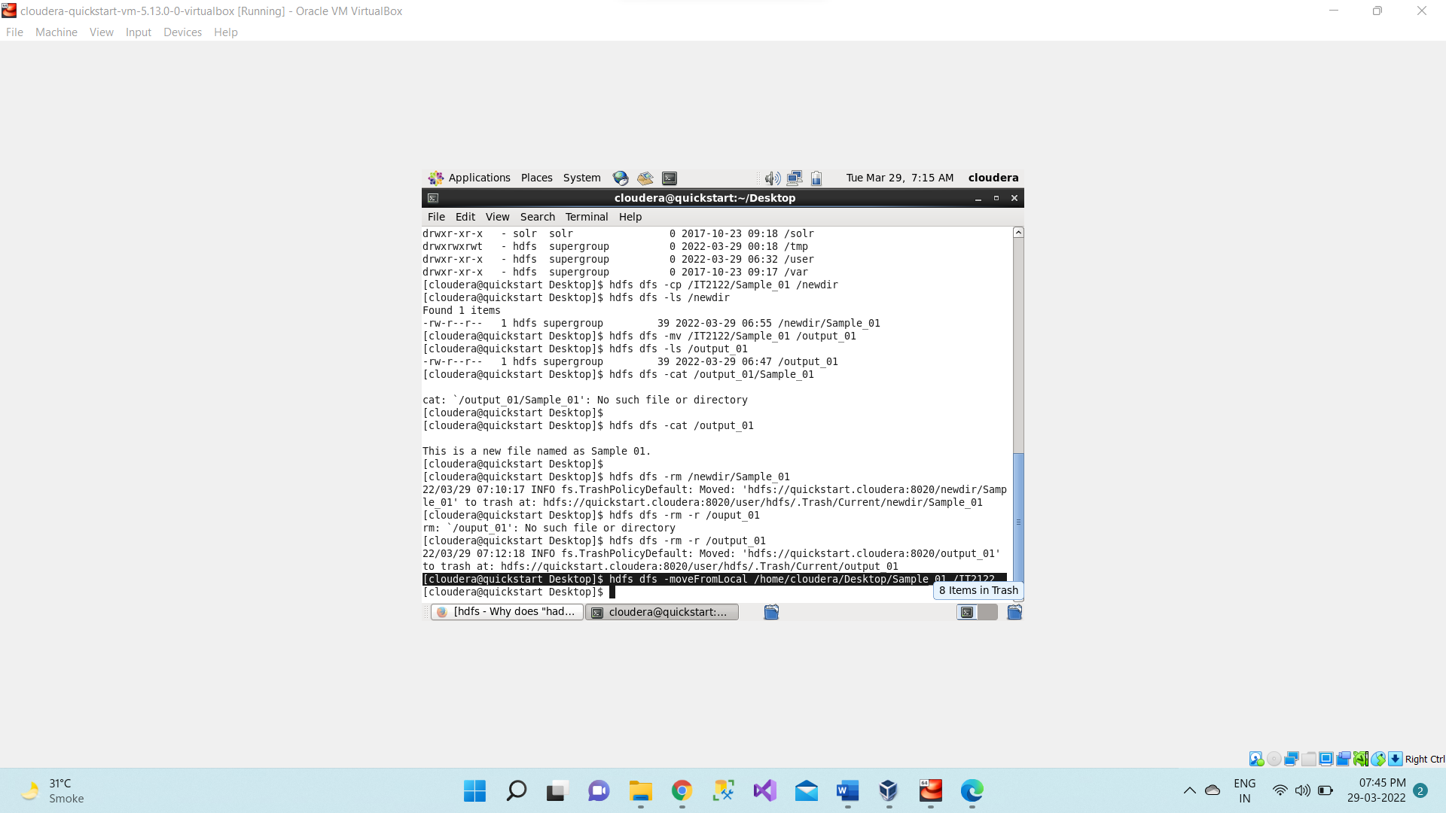

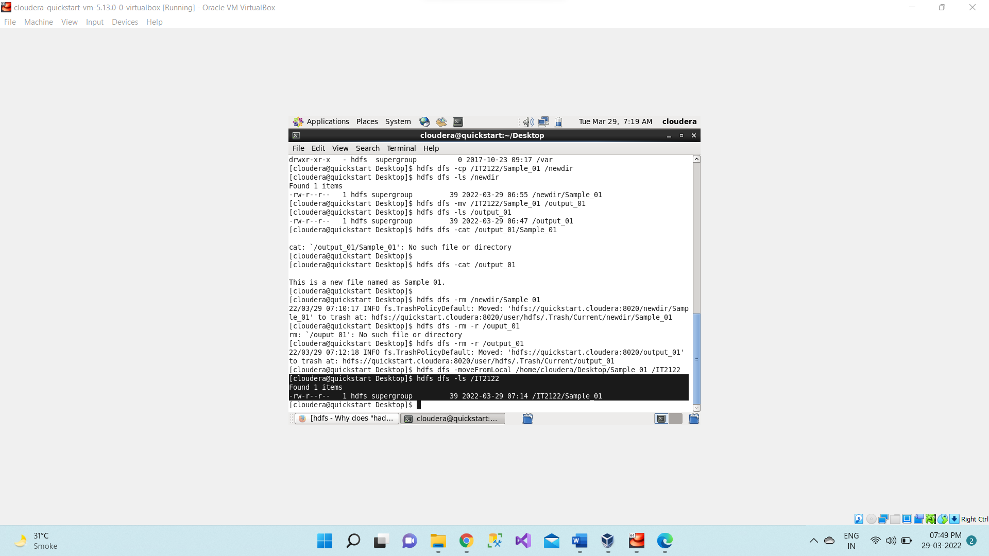

1. **hdfs dfs -moveToLocal /<new_dir_name>/<file_name> /home/cloudera/Desktop/<file_name>** moves files.

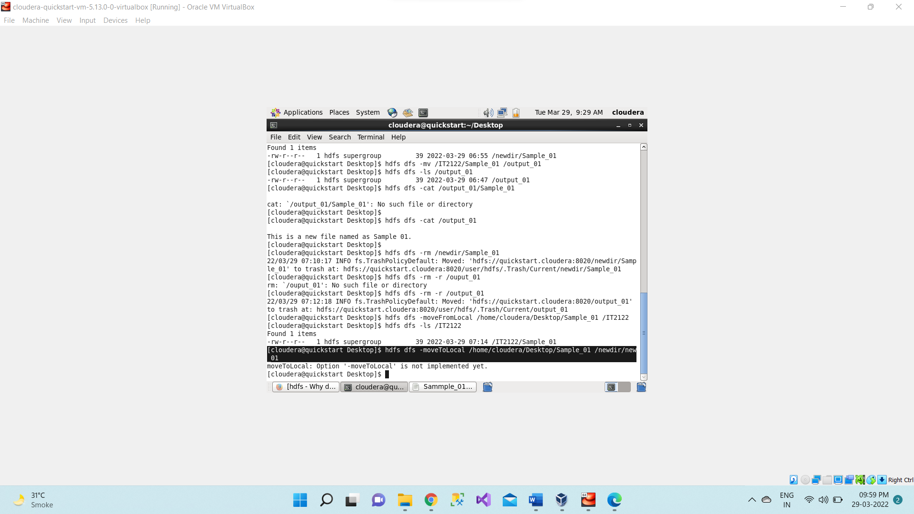

1. hdfs dfs -tail /<dir_name>/<file_name> shows last 1KB of file

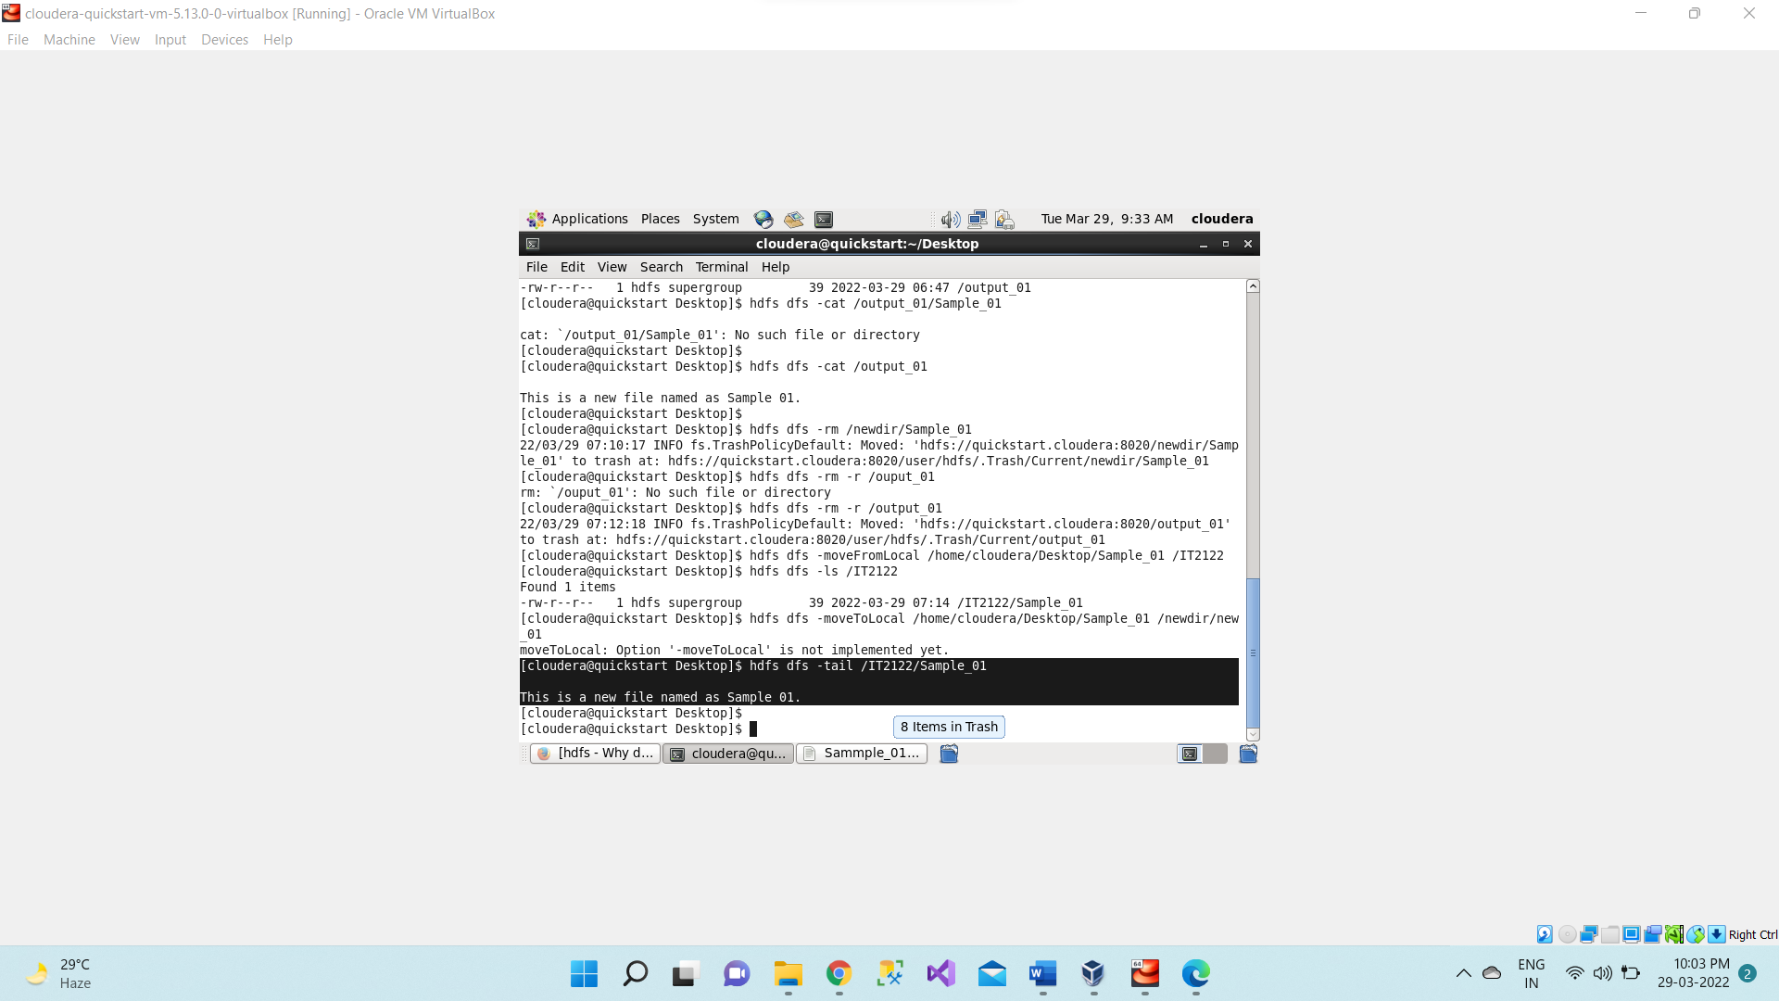

1. **hdfs dfs -expunge** empties the trash available in HDFS

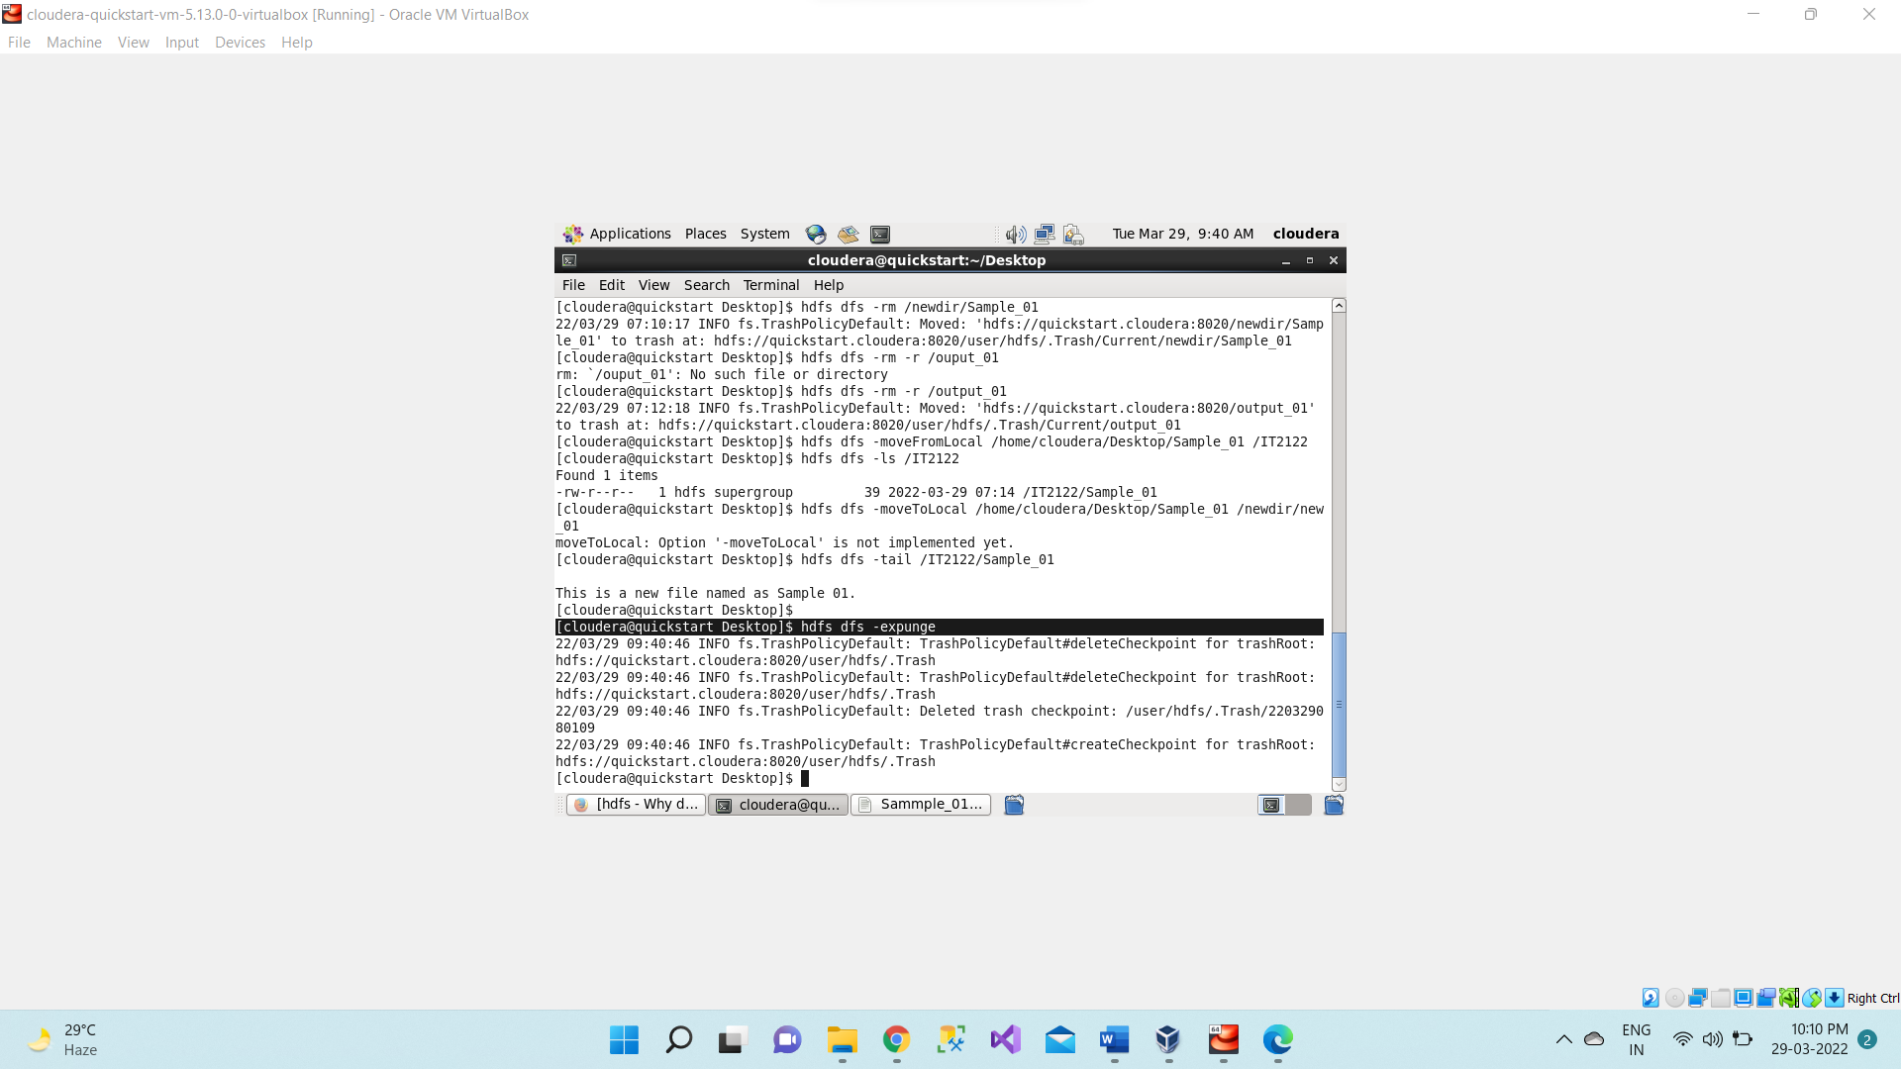

1. First go to local host at localhost:50070 click on Utilities and select browse the file system

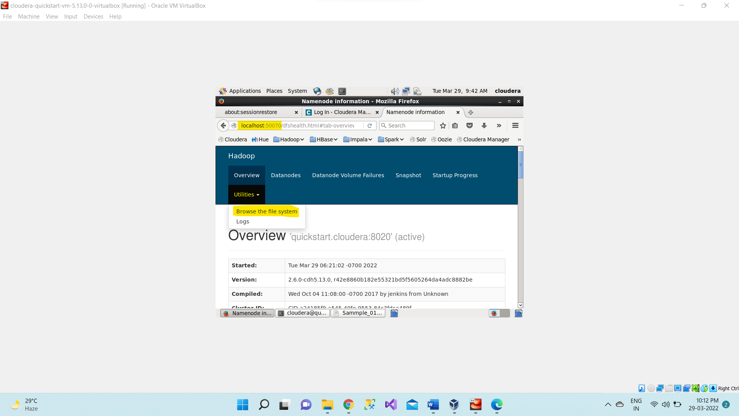

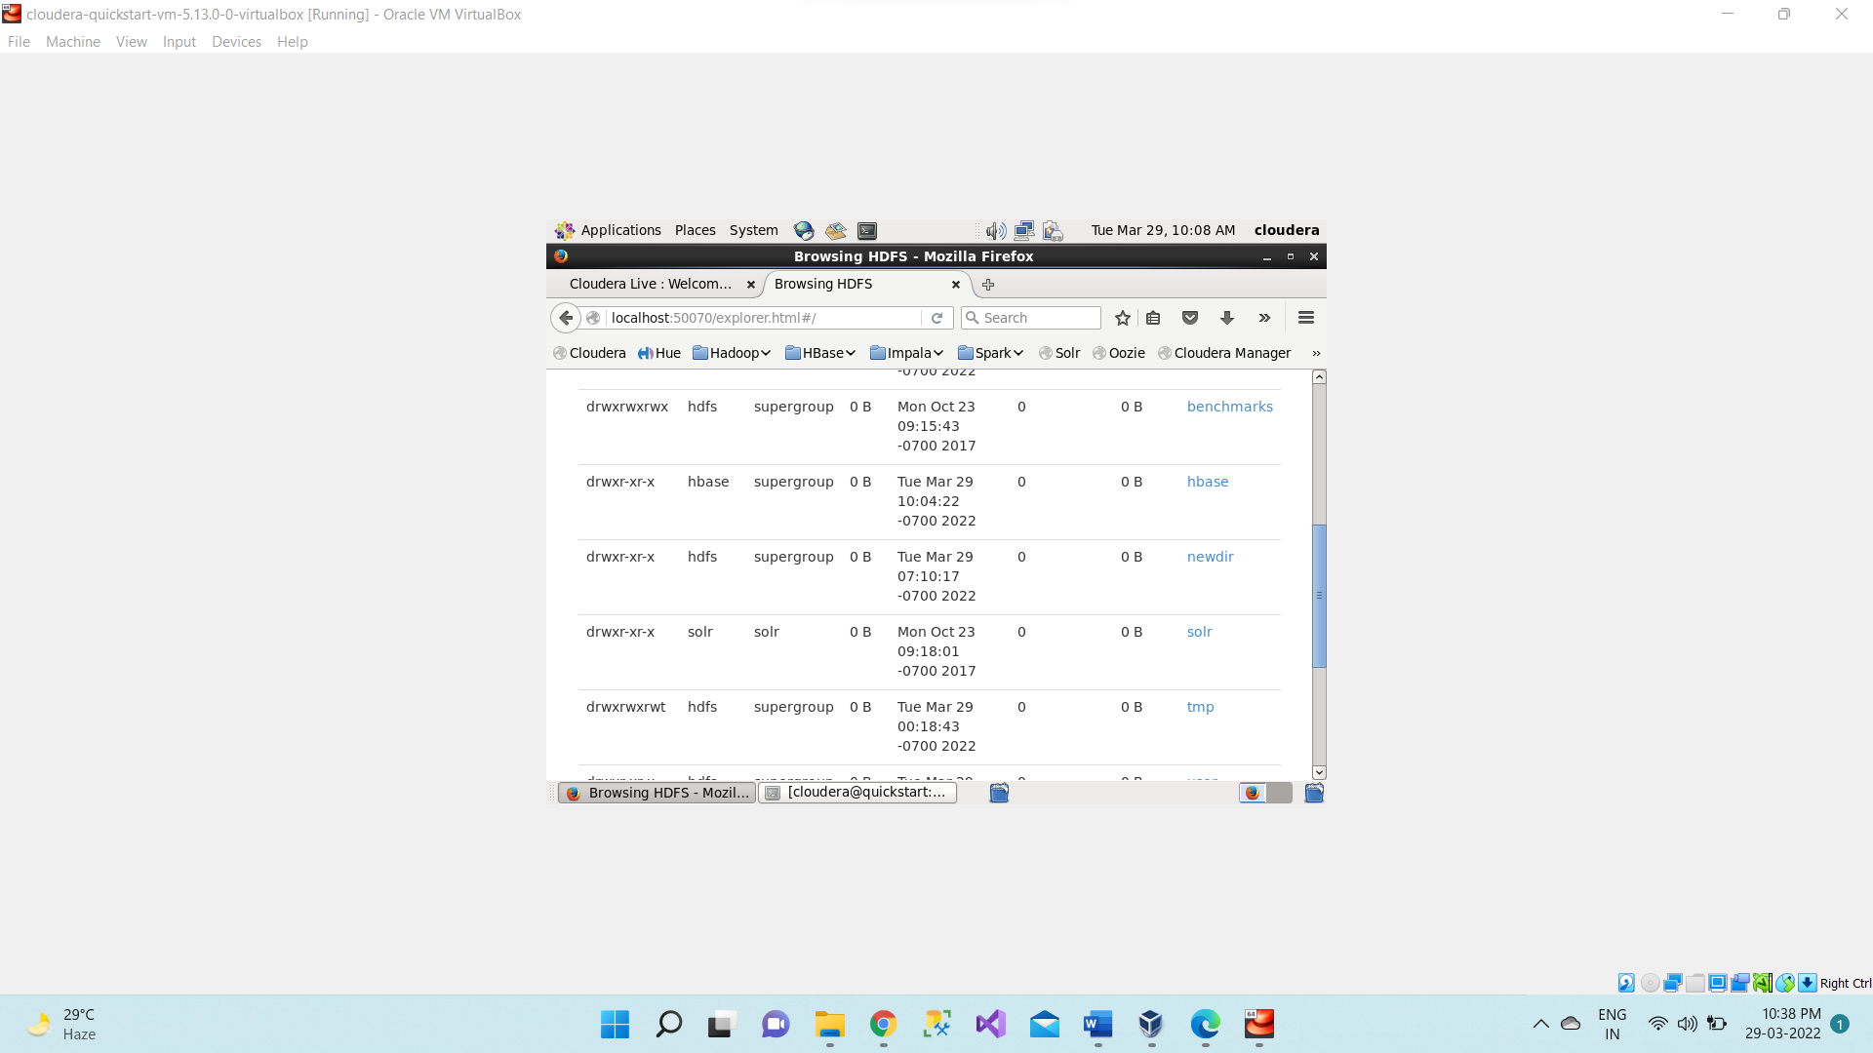

1. **hdfs dfs -setrep 4 /<dir_name>** sets replication of files in specifies directory 4 times.

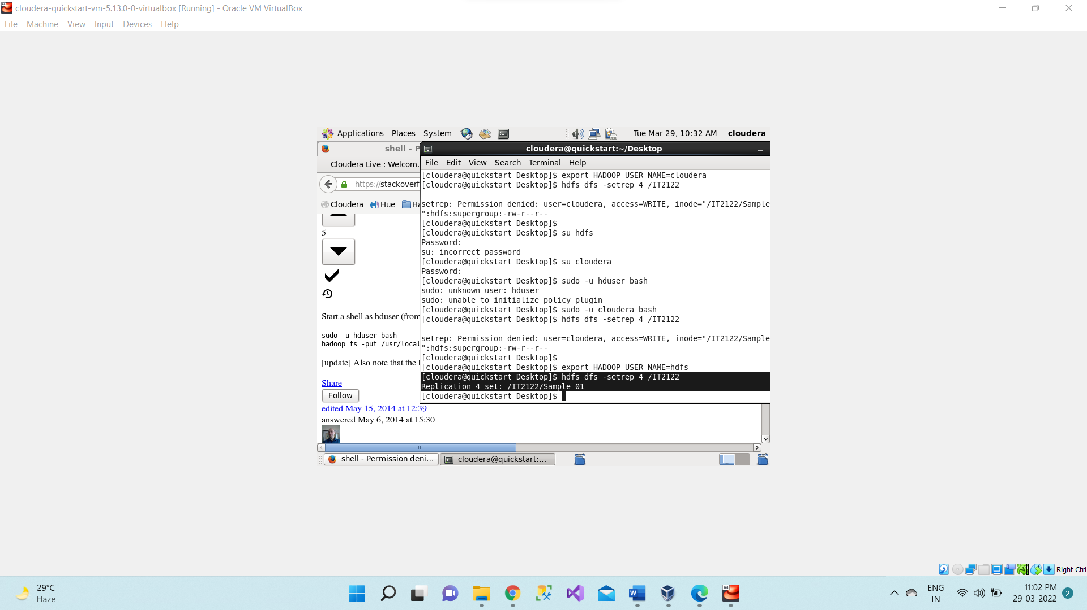

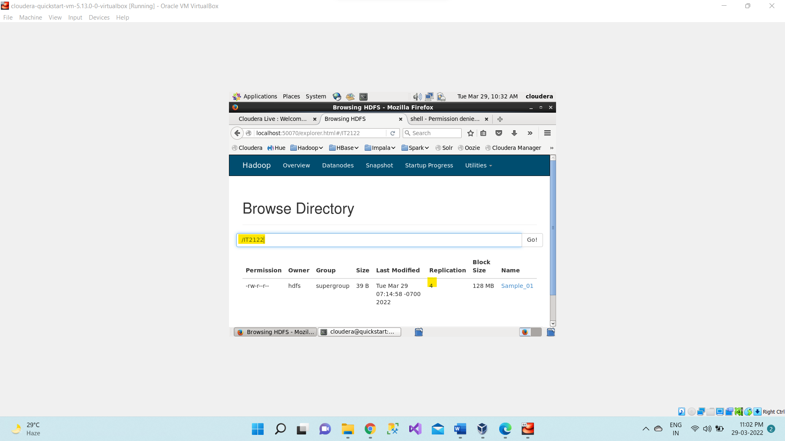

1. **hdfs dfs -du /<dir_name>** gives size of a directory in HDFS

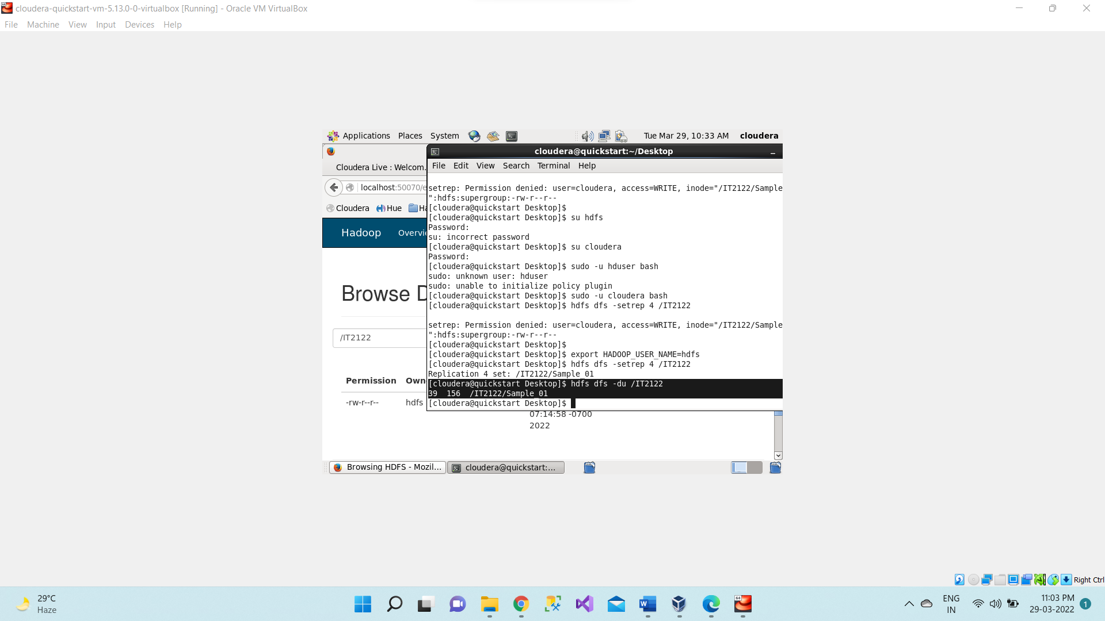

1. **hdfs dfs -df** gives amount of space in use and space available on currently mounted file system

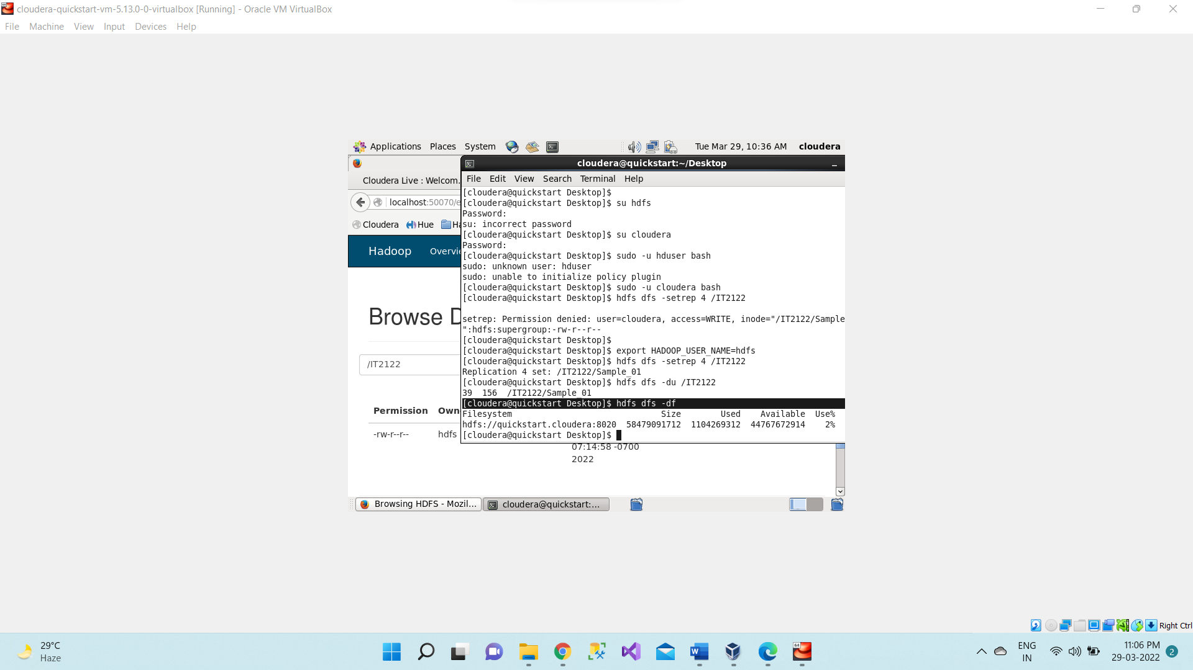

1. **hdfs dfs -df -h** gives space in gb and mb abbreviation

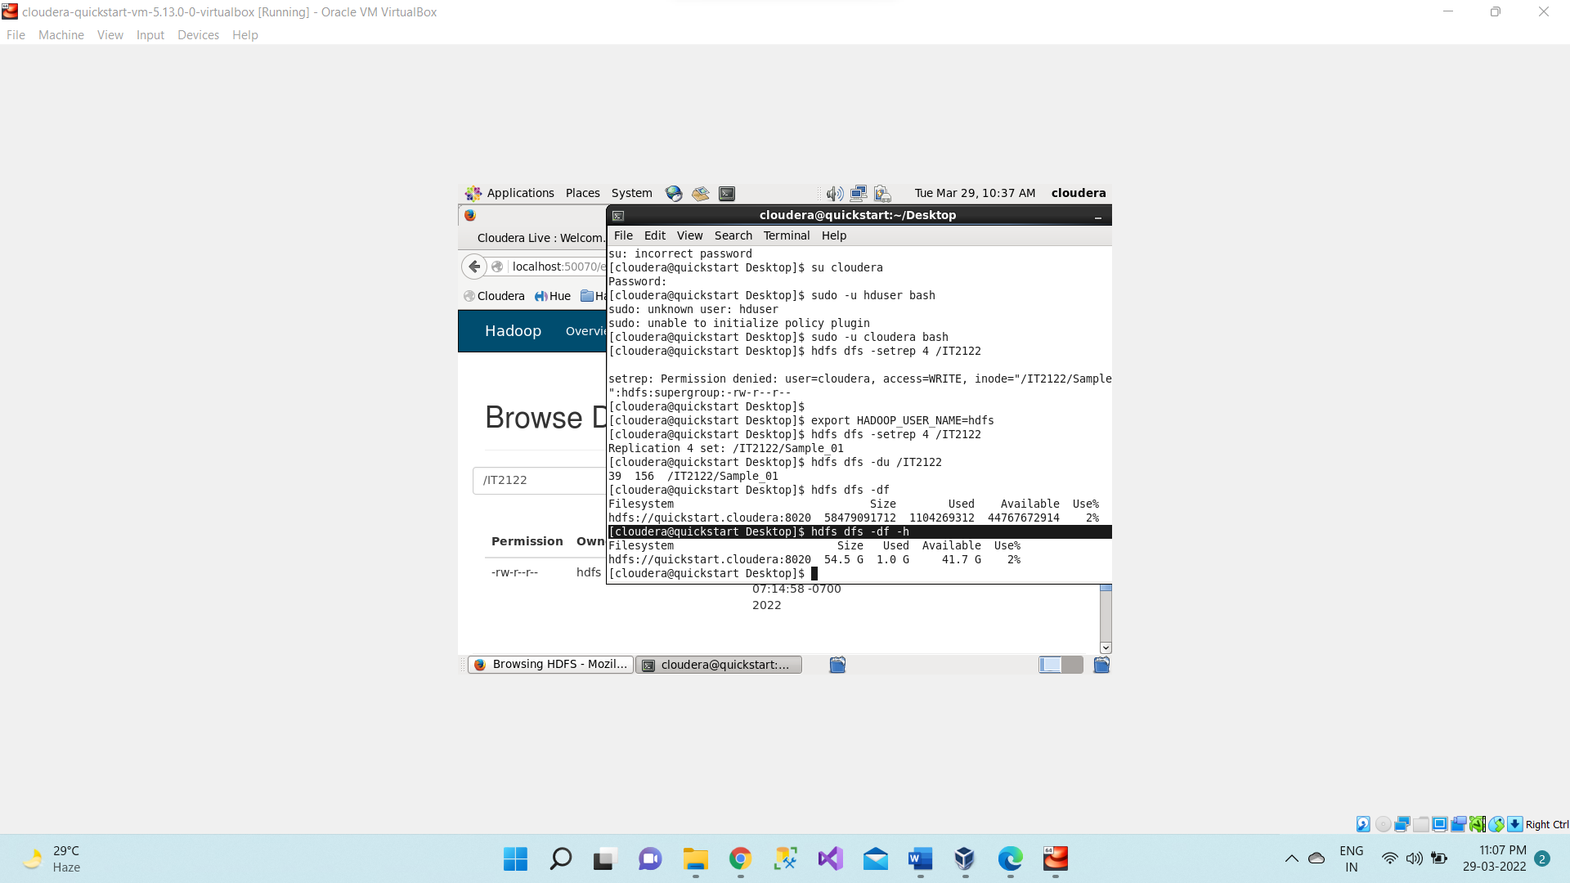

1. **hdfs fsck /<dir_name>** checks health of HDFS and moves corrupted files to lost+found directory or it delete a corrupted file present in HDFS.

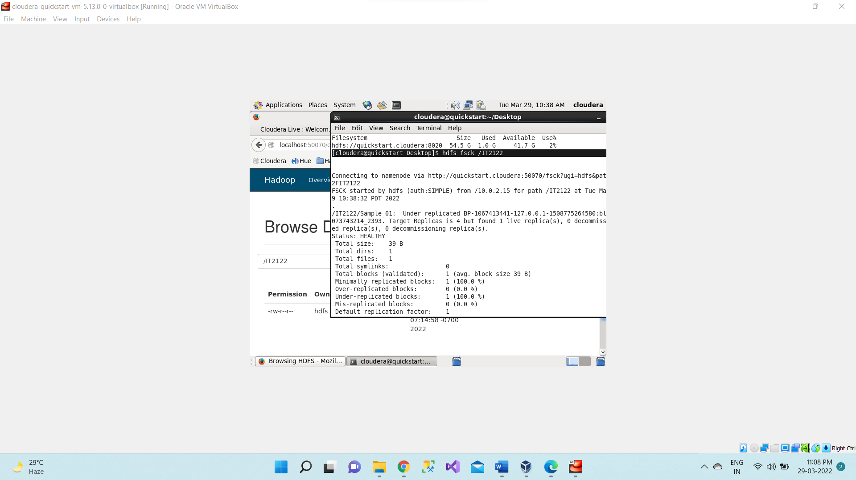

**hdfs fsck /IT2122 -files** prints out the files being checked.

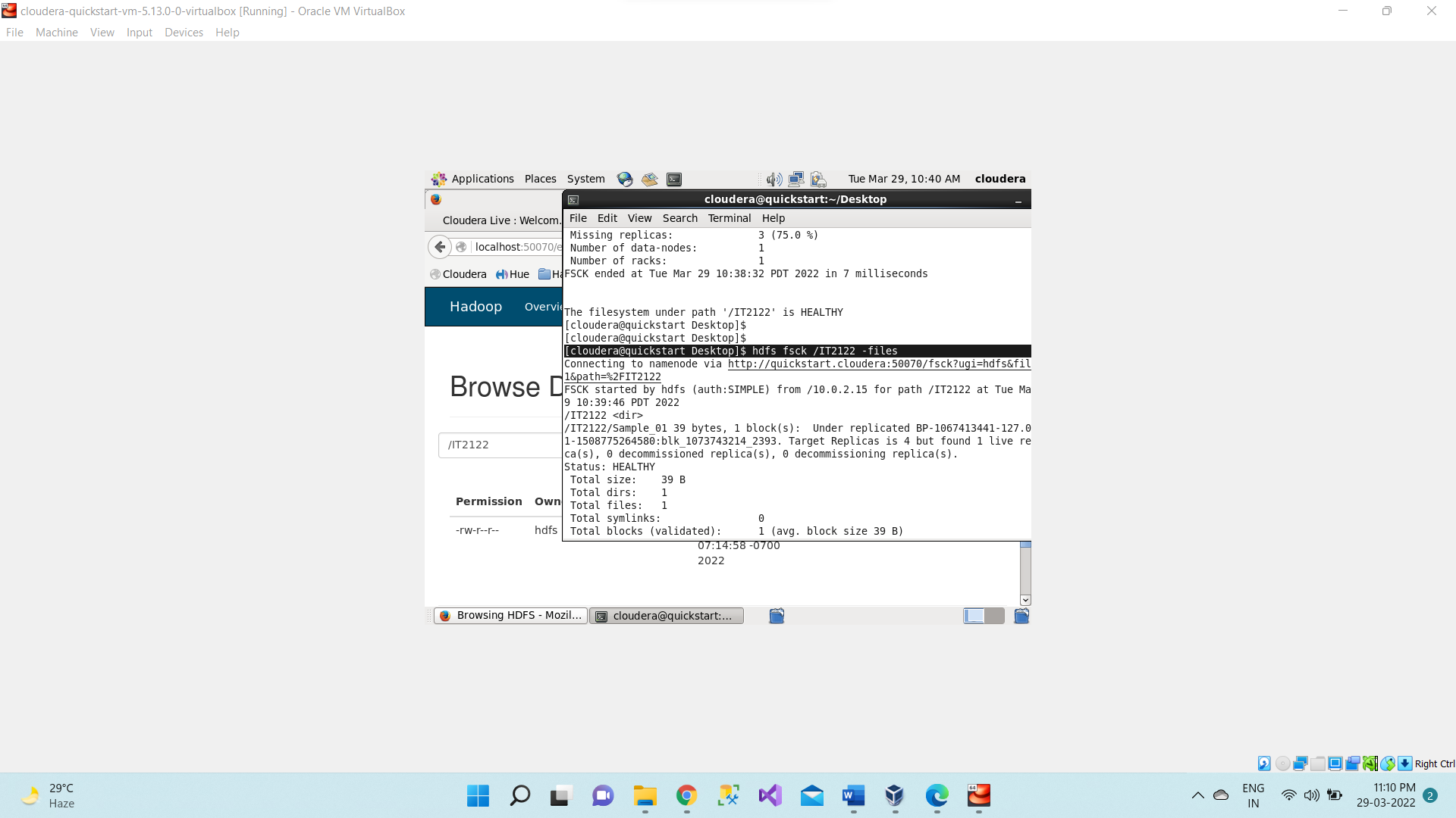

1. **hdfs dfs -touchz /<dir_name>/<emt_file_name>** creates an empty file.

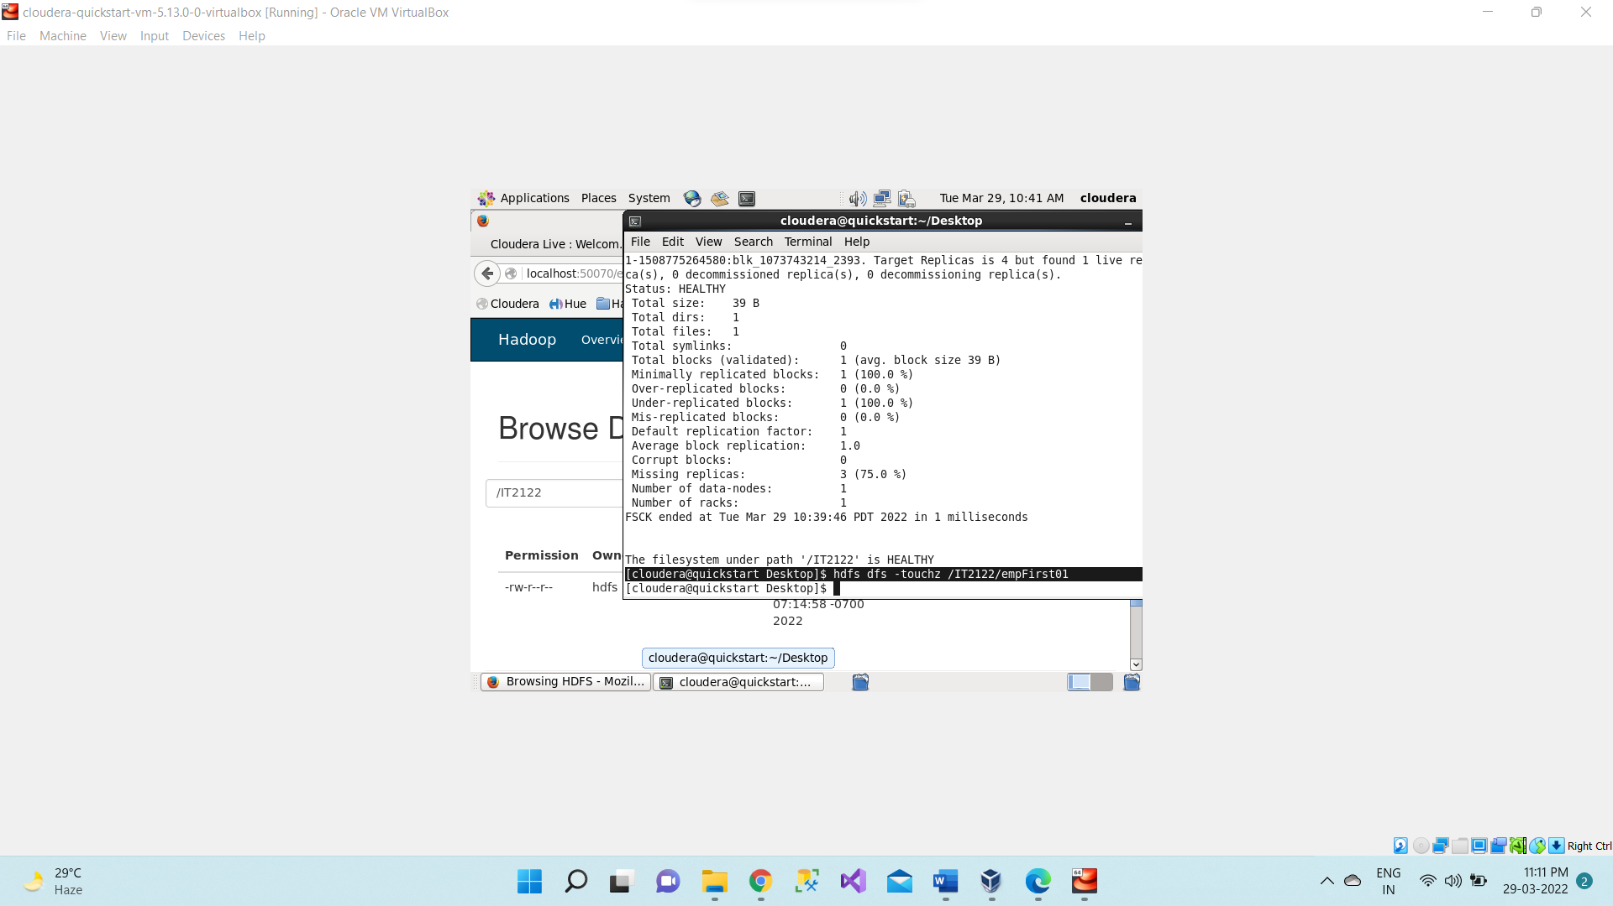

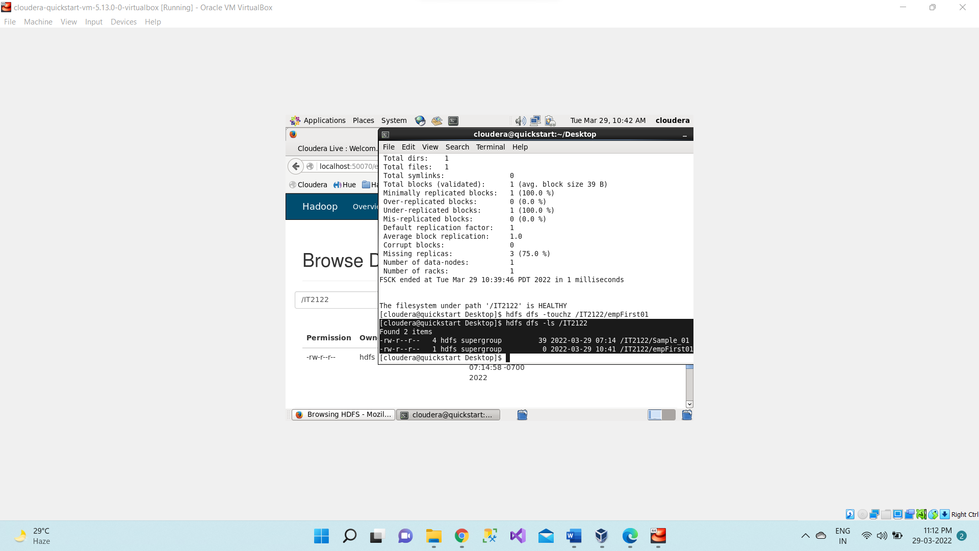

1. **hdfs dfs -stat /<dir_name>** prints statistics about the file or directory it shows recent date of modification.

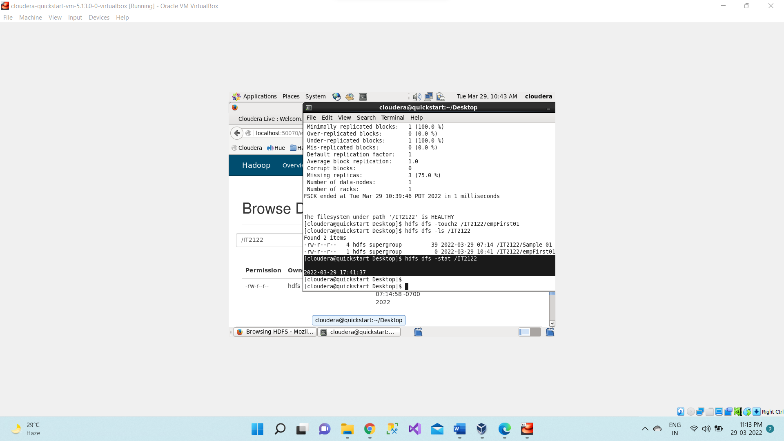

**hdfs dfs -stat %b /<dir_name>/<file_name>** gives file size in bytes.

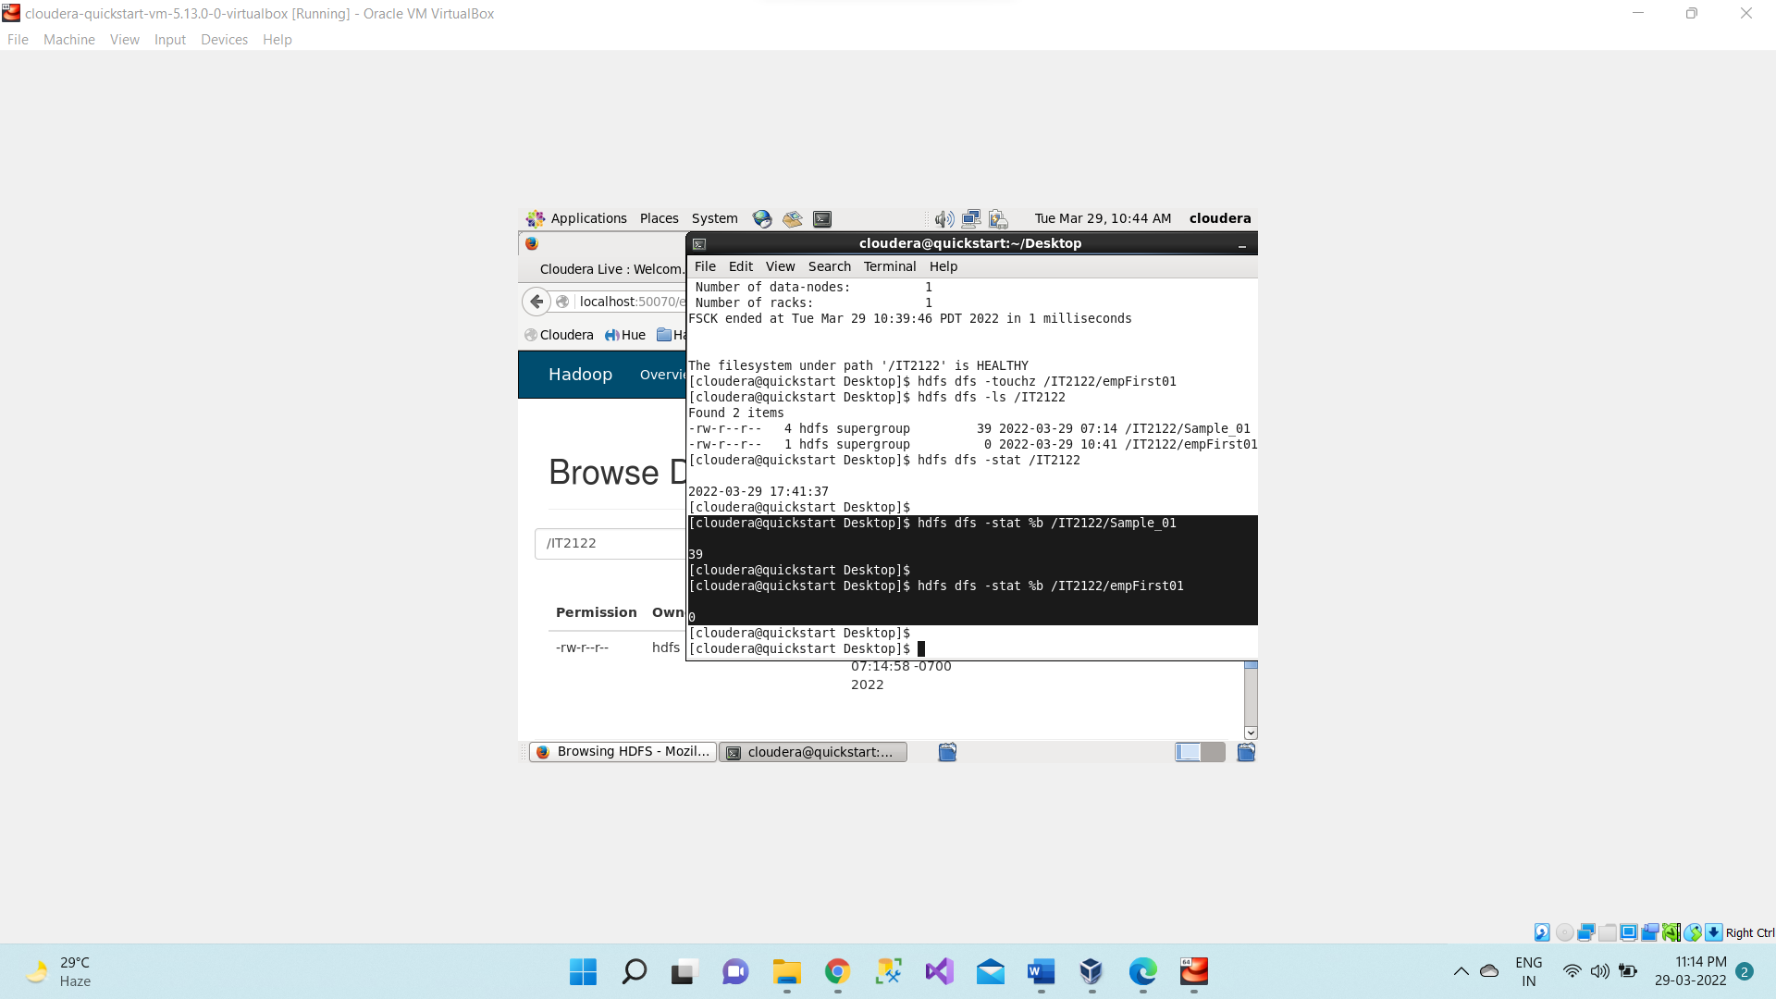

**hdfs dfs -stat %o /<dir_name>/<file_name>** gives block size of file.

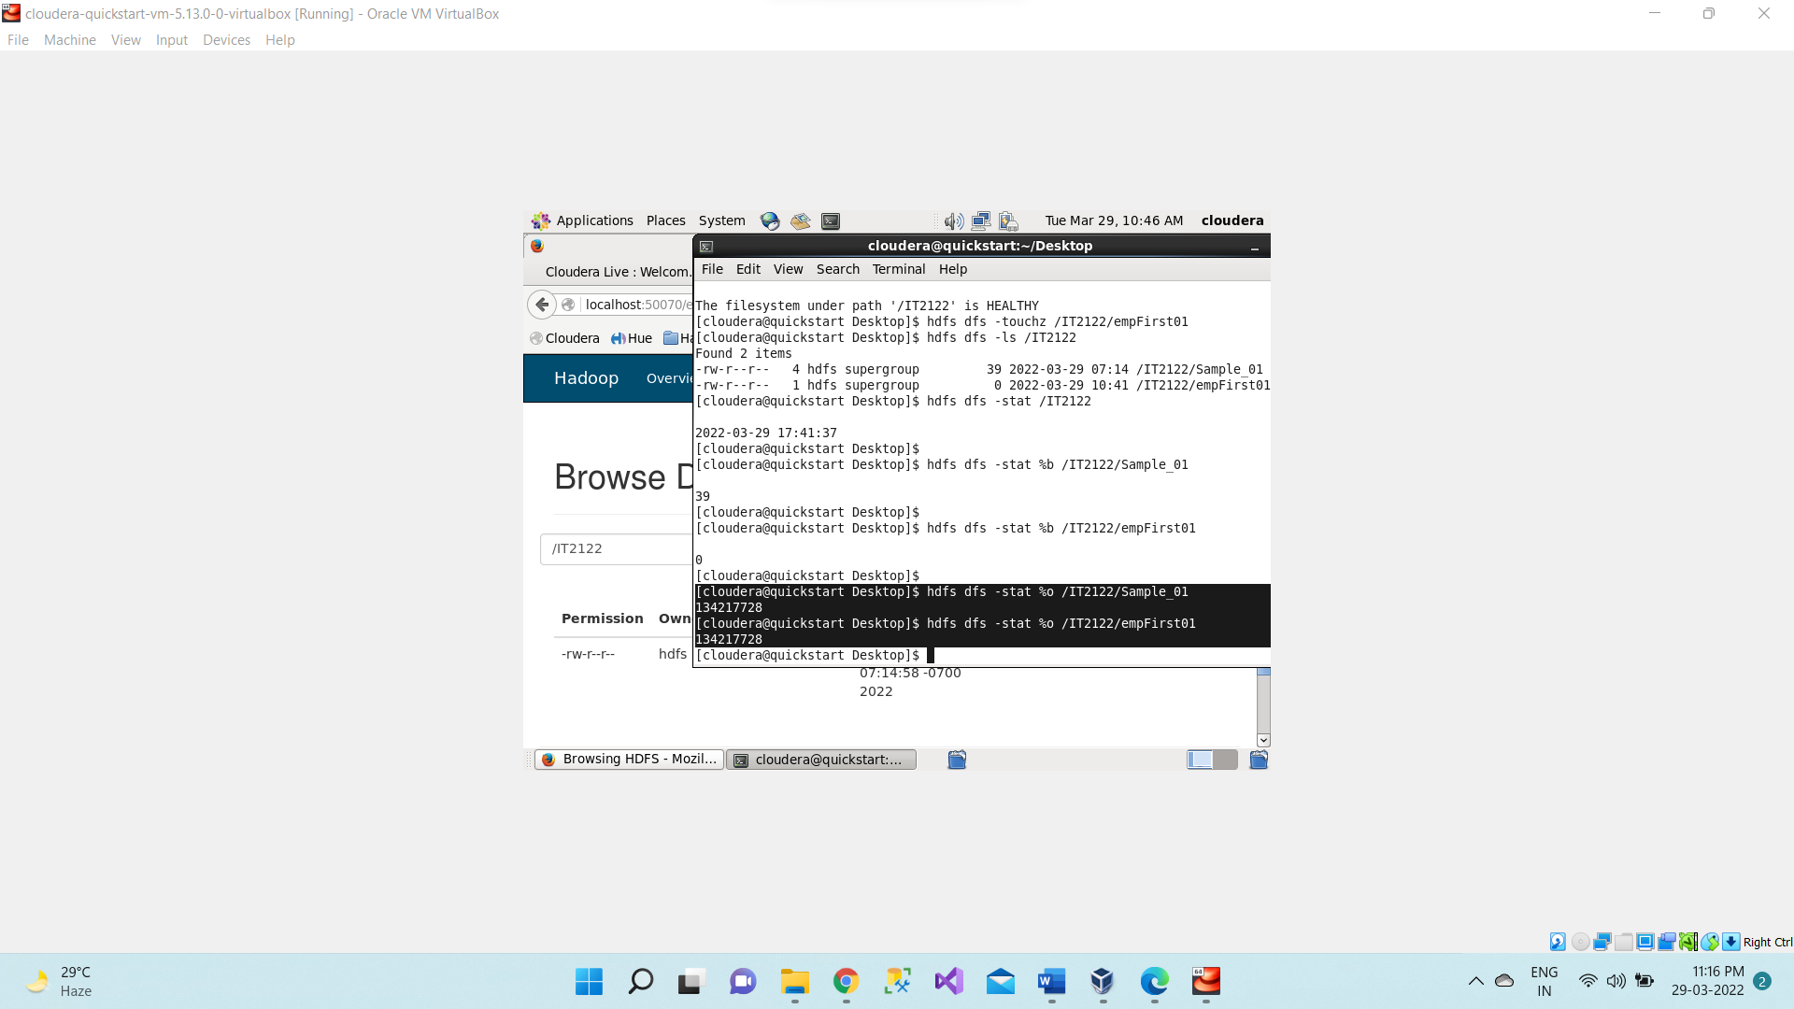

**hdfs dfs -stat %r /<dir_name>/<file_name>** gives no. of replication of file.

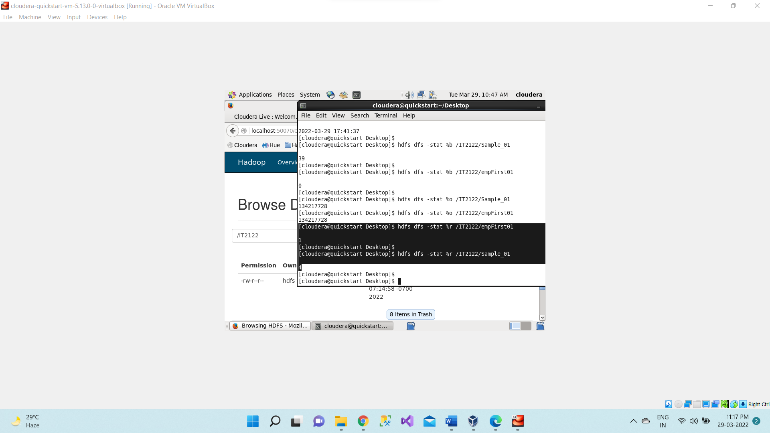

**hdfs dfs -stat %y /<dir_name>/<file_name>** gives last modification date.

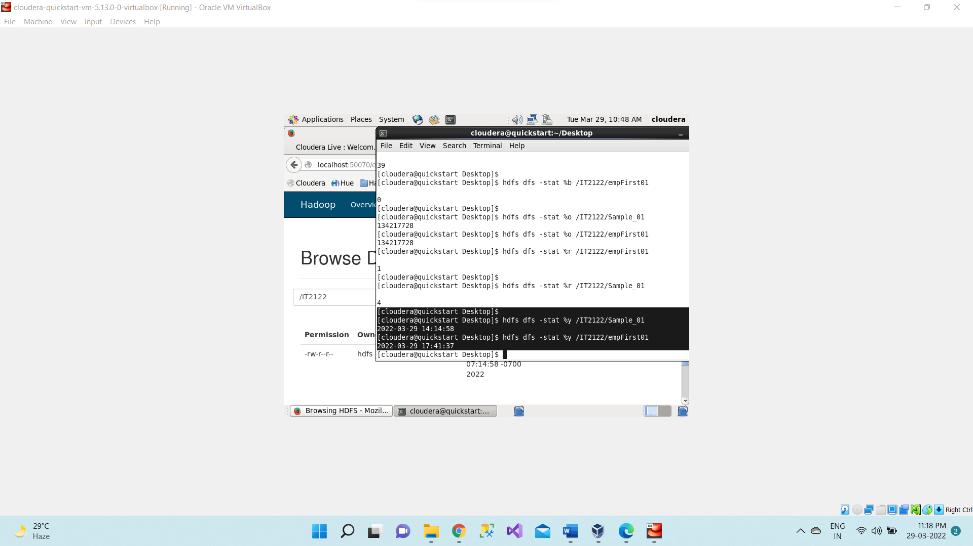

**hdfs dfs -checksum /<dir_name>/<file_name>** gives checksum of file.

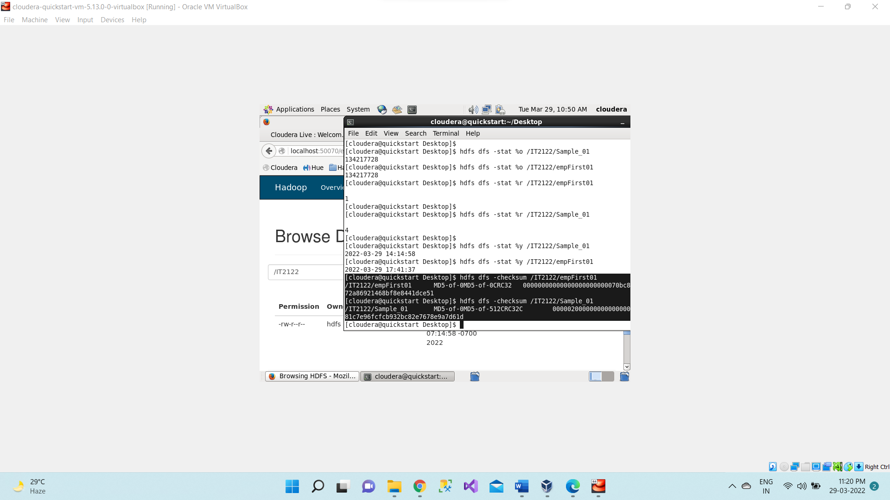

1. **hdfs dfs -help rm** shows **syntax of whereas** commands

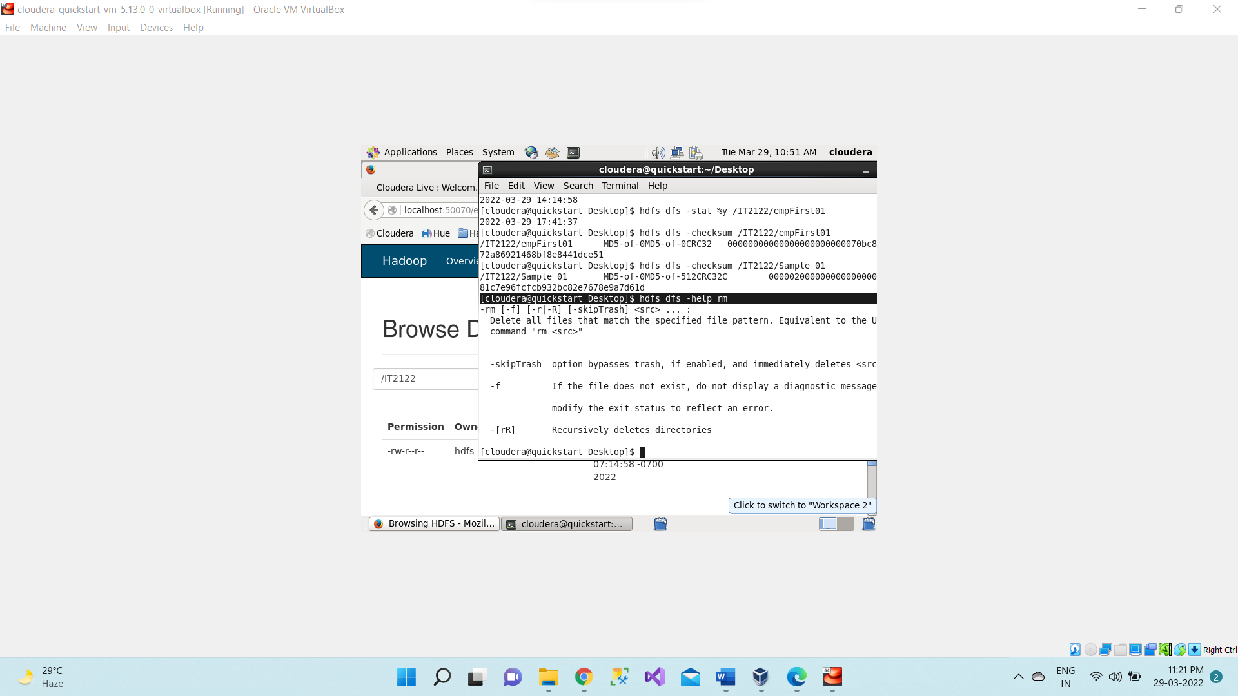

1. **hdfs dfs -get /<dir_name>/<file_name> /home/cloudera/Desktop** copies file from HDFS to local file system

